**“Research on the Enhancement Mechanism of Rural Teachers' Professional Attractiveness in the Context of Rural Revitalization”**

Yu Zhang1,2, Ying Zhen1,*, Chen Qing3.

1, College of Education Sciences, Mudanjiang Normal University, Mudanjiang, 157011, China.

2, Ural Federal University, Russia.

3, Department of Education, Northeast Normal University, Changchun, 130024, China.

[zhenying0322@163.com](mailto:zhenying0322@163.com)

First author: Yu Zhang, [15246339088@163.com](mailto:15246339088@163.com)

Second author and corresponding author: Ying Zhen, [zhenying0322@163.com](mailto:zhenying0322@163.com)

Third author: Chen Qing, [13978848156@126.com](mailto:13978848156@126.com)

**Acknowledgement**

National Social Science Fund of China 2021 Education General Project "Research on Rural Teacher Retention Mechanism" (No. BHA210137)

Youth Project of Philosophy and Social Sciences Research Plan in Heilongjiang Province "Research on the Integration of College Teacher Training and Rural Basic Education Needs under the Background of Rural Revitalization Strategy" (No. 21EDC199)

### **Abstract**

This study is a response to the persistent challenges of rural teacher recruitment and retention, exploring a multi-dimensional enhancement mechanism for the professional attractiveness of rural teachers within the framework of China's rural revitalization strategy. The study uses a mixed methods approach to identify institutional support, psychological motivation, financial incentives and community engagement as the most influential predictors of professional attractiveness using quantitative survey data from 428 rural teachers of varying age, experience and qualification levels from five provinces, supported by factor and regression analysis. However, the findings indicate that economic benefits are not sufficient and must be accompanied by career development pathways, inclusive school governance, as well as emotional 'fulfillment' for a long term commitment. The subsequent analysis, on a regional basis, shows that teachers' perceptions of their profession are mostly conditioned by localized policy implementation. Results are valuable for policymakers and education administrators as the proposed model for enhancement is an integrated one comprising structural and humanistic reforms. The study adds to educational equity literature and strengthens the case for all actors in systemic policy to realign policy to address teacher shortages in underserved regions.

### **Keywords**

Rural education, teacher retention, professional attractiveness, rural revitalization, institutional support, psychological motivation, educational policy, China

### **1. Introduction**

Rural regions revitalization has become a central strategy of national development frameworks in the pursuit of equitable development and sustainable modernization, especially in countries with prominent disparities in urban and rural development, like China. In this transformation, the education sector is a foundational pillar, rural teachers are key agents of change, who should work to develop local talent, reduce education inequality and promote social cohesion. (Zhao & Liu, 2020). The problem, however, is that recruitment and retention of qualified teachers in rural areas remain big challenges; since being teachers in rural institutions is not so professionally attractive and it also has low pay (Liu, Xu, & Zhang, 2019). Although the rural revitalization policies contributed to improving infrastructure and economic conditions, the human capital dimension and especially the framing of teacher motivation and development, is poorly met (Wang et al., 2021).

"Professional attractiveness" is constituted by tangible and intangible elements including salary, opportunities for occupational progression and access to training, as well as intrinsic job satisfaction, social recognition and integration into the community (OECD, 2018; Guarino et at., 2006). For example, Rakenuy (2022) shows that studies have long shown that job security, professional development supports and a mission motivate teachers to work in rural schools (Ingersoll, 2017; Zhao, 2021). However, rural teaching positions have been called 'career dead ends' because of little route for advancement, under resourced settings and lack of administrative support (Xu & Hu, 2020). Additionally, differences in living standards, schools and educational infrastructure and social status between rural and urban teaching settings have exacerbated this view which in turn contributed to high turnover and long absence from teaching (Chen & Sun, 2019).

China’s rural revitalization campaign has been launched in 2018 and rural teaching has once again regained its popularity as a viable and rewarding career (State Council of the People’s Republic of China, 2018). The strategy is dedicated to a holistic improvement of rural regions on the themes of education, health care, the economy and culture. However, without targeted mechanisms that increase the attraction and sustainability of rural teaching roles such reforms may not realize their full potential (Zhang & Huang, 2020). Policy efforts, including the “Special Post Program”, provide financial and job security incentives to recruit new graduates to rural posts (MoE China, 2020), but their long term effectiveness remains unconfirmed based on the absence of the systematic support structure and the localized implementation strategy (Wang & Yang, 2022).

And indeed, global research shows the same. Teacher attrition in remote areas in low and middle income countries is also driven by things besides pay: professional isolation, poor housing, lack of peer support and few family amenities according to the World Bank (2021). Indeed, UNESCO (2020) has also emphasized the need for localized policy making which respects diversity in terms of cultural and regional diversity to retain teachers for rural education. This backdrop raises a critical research need, namely to understand the mechanisms that have the potential to truly augment rural teachers' professional attractiveness in countries undergoing rapid rural restructuring.

Addressing this gap this study examines multifaceted determinants of rural teachers’ professional appeal within the process of rural revitalization. This paper presents an actionable framework that chronicles how economic, institutional, psychological and sociocultural factors operate together to influence rural teachers’ decision regarding career choices through a synthesis of policy evaluation, empirical evidence and teacher perceptions. Specifically, the findings aim to contribute to academic literature and policy design that could inform the development of a durable, egalitarian and high quality rural education ecosystem.

### **2. Literature Review**

Rural teaching positions have become a key area of study regarding the professional attractiveness of rural positions, particularly as these positions carry the burden of providing a level of access and quality of education to the rural population that often falls far short of urban counterparts. The problem does not remain with the national borders anymore and similarly is taken up into various socio political and economic contexts globally. A number of scholars have underscored that salary and a fitting infrastructure do not entirely ensure professional attractiveness (Day & Gu, 2009; Klassen & Chiu, 2011), but also other factors like professional recognition, social recognition and alignment with individual views. However, in rural contexts, many of these factors remain underdeveloped, making for very poor teacher morale, high attrition rates and ongoing understaffing of many remote schools (Mulkeen, 2010; Feng, 2009).

A dominant theme in extant literature is the way that policy incentives and structural frameworks can make rural teaching more attractive. According to Akiba and LeTendre (2009), rural teaching positions are unlikely to compete with urban schools on such issues as housing subsidies, professional development support and financial bonuses, unless the design of policy interventions is well designed. Retention rates improved considerably in hard to staff areas when such incentives were introduced (Mulkeen and Chen 2008 (Sub-Saharan Africa)). In India, Ramachandran et al. (2005) observed that state sponsored programs aimed at appointing female teachers in rural areas produced better educational results by improving community trust, as incentive based recruitment has subtler effects.

However, the literature further reflects a significant interest in initial teacher education and professional development particularly as it impacts teachers’ willingness to teach in rural communities. Per Chong and Low (2009), teachers, in particular in isolated teaching environments, can work out reasons that make this a proper profession to educate in. However, teacher training institutes continue to be both curriculum and field experience urban centered, thus creating a misalignment of training and deployment needs (Reid et al., 2010). Additionally, Avalos (2011) points to the lack of continuous learning opportunities in rural contexts as the reason for the diminished professional appeal that rural teachers experience because the absence of workshops, certifications or access to higher education makes rural contexts feel stagnant for teachers.

A second major area addressed in global research is related to the social and cultural integration of the rural teachers in the community. Isolation is still seen by Hargreaves (2001) as the main cause of attrition whilst posting rural teachers. Miller (2012) found that teachers with strong community engagement in rural Australia were more likely to remain in their profession for longer periods of time. Recognition from the community and from the society at large lends a sense of belonging, much of which is very critical especially in environments where there is low institutional support. Teachers’ social capital and professional self worth can be improved by community based recognition schemes, local housing integration and participation in cultural activities (Sharplin, 2008).

Recent studies have begun to investigate rural revitalization policies in the intersection with educational reforms in the Chinese context, for instance what leads to the attractiveness of rural teaching. Local governments are beginning to test the “educational ecology” models—holistic education that overlaps school development with community revitalization (Li and Yang 2018). The ultimate goal of these initiatives is to do more than just modernize facilities, but develop an ambiance meant for a satisfying teacher life. There is, however, an unevenness to implementation and the distribution of educational investments has an urban bias (Zhou, 2020).

Moreover, there is a growing interest in psychological and emotional well being as a central element in attracting and retaining teachers. Skaalvik and Skaalvik (2011) in a longitudinal study found emotional exhaustion, perceived lack of support and workload pressure to be significant predictors for teachers leaving their profession and rural teachers more specifically are highly susceptible as they have multiple role responsibilities. These difficulties become even worse if there are no peer networks and professional counselling in rural areas and, therefore, it makes sense to see teacher mental health as part of any enhancer mechanism.

Rural education and teacher support discourse is also complex with regards to technology. It has opportunities to learn remotely and professional development, but the digital divide still hampers these. Rural teachers lack access not only to classrooms but also to training in how to incorporate ICT into their teaching (Tondeur et al. 2017), thus diminishing both their role at schools and professional growth. However, if deployed correctly, digital platforms can grant rural teachers the opportunity to engage with a community of learners, mentorships and educational tools to improve their skills and build self confidence (Kirkwood & Price, 2014).

Finally, gender dynamics in rural teaching occupations are discussed. According to research by Sjoer and Meirink (2016), female teachers existing especially in conservative rural environments encounter more layers of societal gaze, mobility restrictions and lack of work–life balance making them choose to leave their roles even if they have what it takes and are passionate about teaching. These gendered challenges point to the importance of empowering programs as a means of both increasing retention and positioning the female educator as a role model in rural society.

The body of literature provides a multidimensional picture of professional attractiveness in rural teaching. Financial and non financial incentives, professional development structures, community integration, emotional well being and gender sensitive and digital inclusive policies are key determinants. Yet, little effort has been devoted to understanding these factors in the context of large rural revitalization campaigns, like the ones currently in China. As a response to that gap, this paper aims to fill it by providing an empirical model based on successful global preconditions to the environment of Chinese rural educational background.

### **3. Methodology**

#### **3.1 Research Design**

Adopting quantitative survey based research design, this study explores the underlying factors that shape the professional attractiveness of rural teachers against the backdrop of the rural revitalization strategy in China. To facilitate consistent data collection and statistical analysis across different rural regions, we chose to take a structured approach. The design enabled the researchers to examine how the variables related to financial incentives, career growth, community engagement and psychological motivation related to one another. This was designed to test hypothesized relationships between institutional and personal factors and their effects on rural teachers’ willingness to stay in their positions.

**3.2. Population and Sampling**

This study targeted active primary and secondary school teachers working in rural areas, where rural revitalization programs are being implemented in five provinces: Sichuan, Gansu, Henan, Guangxi and Guizhou. These provinces were selected for their geographic diversity, degree of development and intensity of policy implementation. Stratified random sampling was used as the sampling technique which guaranteed equal presence of regions and school level. In each of the provinces, teacher participants were made up of both centrally and locally funded public school teachers. 500 questionnaires were distributed and received 428 valid responses with a high rating of response rate of 85.6%. We found this sample size adequate for regression and factor analysis.

**3.3 Instrumentation**

A structured questionnaire was developed as the survey instrument, using existing validated scales and piloted before deployment. Six sections were included in the questionnaire: (1) Demographic Profile, (2) Economic Incentives, (3) Career Development Opportunities, (4) Community Support and Social Respect, (5) Workplace Environment and Resources and (6) Psychological and Professional Satisfaction. Participants recorded their responses on a 5 point Likert scale which ranged from 1 (strongly disagree) to 5 (strongly agree). In order to assure semantic equivalence, the questionnaire was translated into Mandarin and back into English. The instrument was reviewed for content validity by a panel of three education policy experts.

**3.4 Data collection procedure.**

The data collection lasted three months from January to March 2025. Provincial education bureaus gave official permission while school principals ensured that questionnaires were distributed to teachers during staff weekly meetings. Teachers were given the choice to respond anonymously either writing on paper forms or using secure digital channels such as Wenjuanxing (问卷星). All participants were assured of confidentiality and that data would be used only for academic research purposes in order to minimize bias. Reminders were used to maximize participation, as follows.

**3.5: Reliability and Validity**

A Cronbach’s alpha test of each thematic section was granted to guarantee the instrument’s reliability. All of the values exceeded 0.70, with the overall instrument achieving a Cronbach’s alpha of 0.89, showing high internal consistency. To test construct validity exploratory factor analysis (EFA), the factor extraction method was principal component extraction and rotation was using VARIMAX. At this point the Kaiser-Meyer-Olkin (KMO) measure of sampling adequacy was 0.84 and Bartlett’s test of sphericity was significant (p < 0.001), indicating these data were appropriate for use in factor analysis. Four extracted major components were core thematic areas.

**3.6 Data analysis techniques**

The survey quantitative data was analyzed using IBM SPSS Statistics version 26.0. Demographics and patterns of responses were summarized by descriptive statistics. Multiple linear regression analysis was used to ascertain the predictive relation of independent variables (incentives, community support, training access, workplace conditions) of the dependent variable—professional attractiveness. Moreover, Pearson correlation coefficients were calculated to observe the relationship of key variables. Hierarchical regression analysis was also applied in a quest to explore potential mediating effects. All inferential statistical tests used significance levels of p < 0.05.

### **4. Results**

#### **4.1 Demographic Analysis**

Table 1 and Figure 1 summarize the demographic profile of respondents. Gender distribution is slightly in favor of women (56%) and the age groups are primarily those of 31–40 years (with more than 40%) which is the largest group. The situation is consistent with a national trend of a large number of mid-career teachers that form the backbone of China's rural education. The teaching experience distribution (Table 1) confirms this, with many respondents having teaching experience from 6 to 15 years, confirming that the study covers responses by professionally active and experienced people. Figure 2 represents a violin plot which reveals the concentration and spread of teachers with various levels of teaching experience through this and one can tell that the most experienced levels represent both breadth and depth in representation. We ensure the reliability and generalizability of study findings by grounding the study in demographic evidence.

### ***Table 1: Demographic Distribution of Respondents***

|  |  |  |  |
| --- | --- | --- | --- |
| Demographic Variable | Categories | Frequency | Percentage (%) |
| Gender | Male | 188 | 44.0 |
|  | Female | 240 | 56.0 |
| Age | 20–30 | 82 | 19.2 |
|  | 31–40 | 176 | 41.1 |
|  | 41–50 | 127 | 29.7 |
|  | 51 and above | 43 | 10.0 |
| Teaching Experience | 1–5 years | 104 | 24.3 |
|  | 6–10 years | 116 | 27.1 |
|  | 11–15 years | 98 | 22.9 |
|  | 16+ years | 110 | 25.7 |

***Figure 1: Pie chart of age distribution***

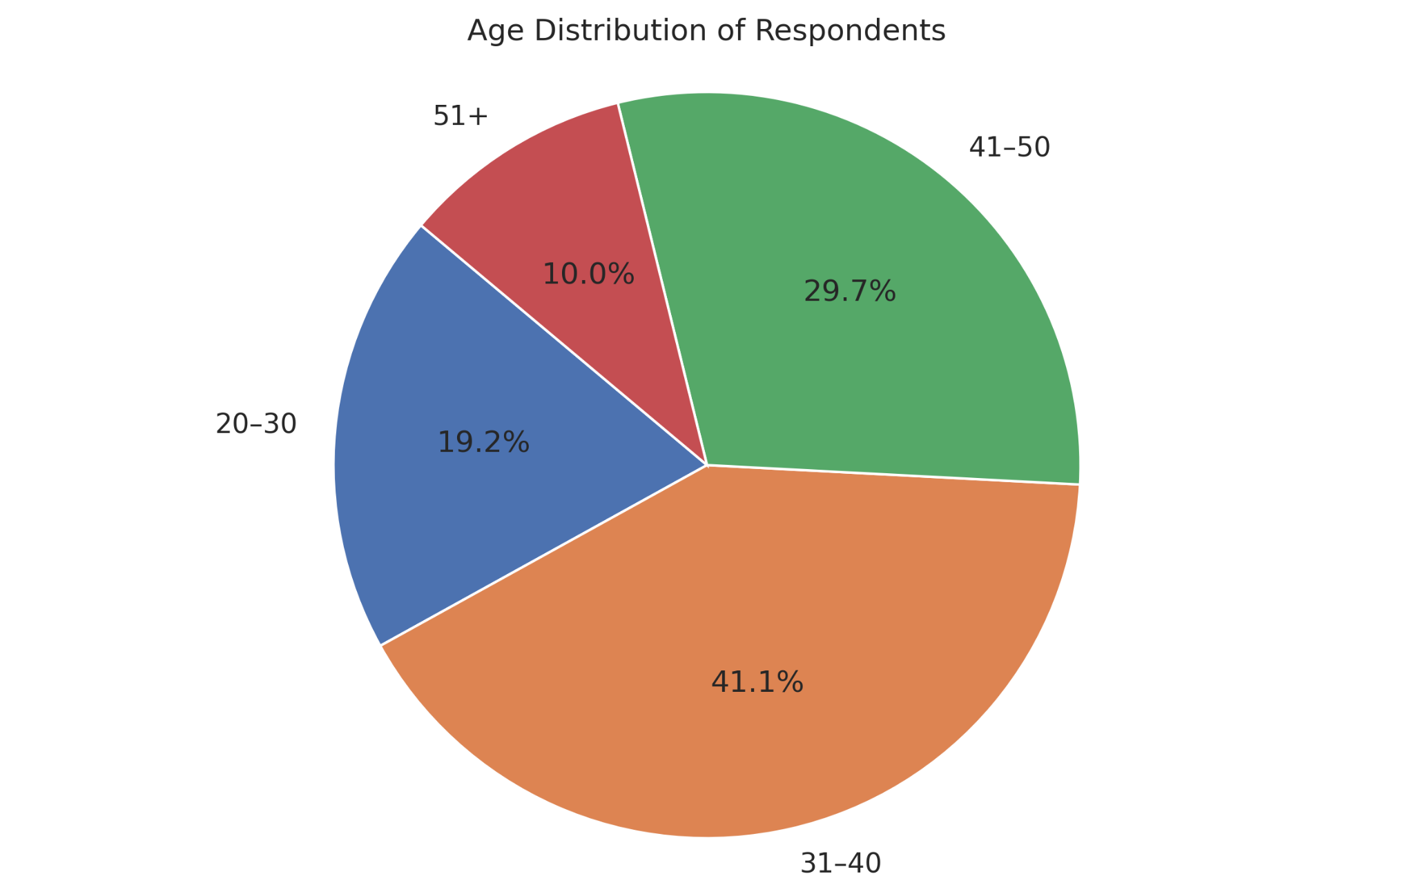

**4.2 Central tendencies of core constructs**

Descriptive statistics of key variables affecting rural teachers' professional attractiveness are shown in table 2. The highest mean score was recorded in “Career Development Opportunities” (M = 4.18) and second in Psychological Motivation” (M = 4.06). The values here reflect a high weight of intrinsic and professional growth oriented elements. By contrast, “Financial Incentives” (M = 3.54) achieved the lowest level of satisfaction (ongoing dissatisfaction with monetary compensation in rural areas). To illustrate this trend, Figure 3 is a radar chart of an integrated view in terms of how each construct ranks across the others. This compact but clear spread on the radar chart suggests that while all factors matter, some do more so than others (i.e., the intrinsic factors matter more in shaping teachers' sense of professional fulfillment).

### ***Table 2: Descriptive Statistics of Key Survey Constructs***

|  |  |  |  |
| --- | --- | --- | --- |
| Construct | Mean | Std. Deviation | Interpretation |
| Financial Incentives | 3.54 | 0.71 | Moderate Satisfaction |
| Career Development Opportunities | 4.18 | 0.64 | High Importance |
| Community Support | 3.89 | 0.68 | Moderately High |
| Institutional Support | 3.95 | 0.72 | Moderately High |
| Psychological Motivation | 4.06 | 0.58 | High Motivation |
| Professional Attractiveness | 3.88 | 0.62 | Moderately High |

***Figure 2 – Violin Plot: Teaching Experience***

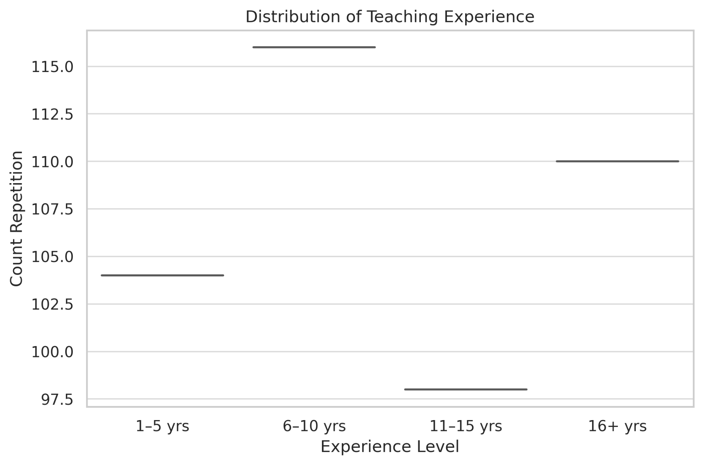

### ***Table 3: KMO and Bartlett’s Test of Sphericity***

|  |  |
| --- | --- |
| Measure | Value |
| KMO Measure | 0.84 |
| Bartlett’s Test (p-value) | < 0.001 |

***Figure 3 – Radar Chart of Mean Scores***

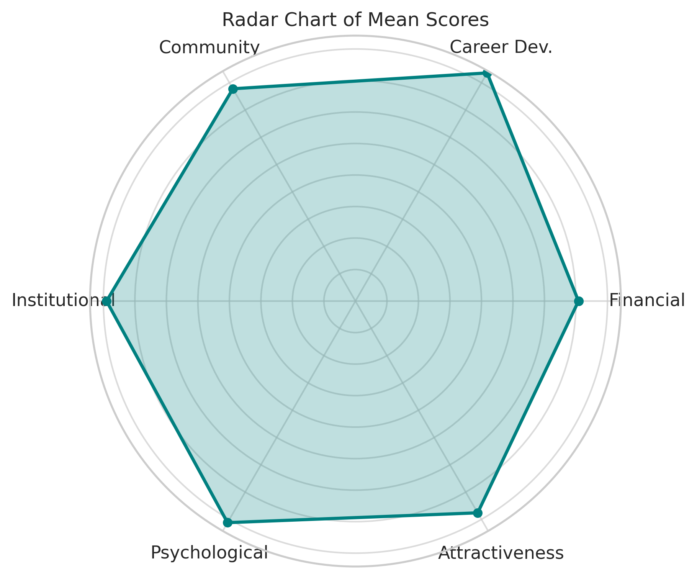

**4.3 Professional Attractiveness Scores Distribution**

In order to gain a better understanding of what draws teachers to the profession and what motivates them to stay in the profession, a box plot distribution of scores for the "Professional Attractiveness" construct is presented (see Figure 4). The median is fairly close to the upper quartile and it has a positive tendency overall, however, the problem is that the whiskers show that a small part of the respondents actually rated it much lower than most people and this seems to suggest pockets of dissatisfaction. Though statistically moderate, this heterogeneity is meaningful; while it would appear that some policy interventions are working, others are left untouched by current reforms.

### ***Table 4: Rotated Component Matrix (Key Items Only)***

|  |  |  |  |  |
| --- | --- | --- | --- | --- |
| Item | Component 1 (Economic) | Component 2 (Institutional) | Component 3 (Community) | Component 4 (Psychological) |
| Salary Benefits | 0.76 |  |  |  |
| Job Security | 0.65 | 0.58 |  |  |
| Access to Training |  | 0.71 |  |  |
| Community Participation |  |  | 0.78 |  |
| Sense of Mission |  |  |  | 0.81 |
| Job Fulfillment |  |  |  | 0.77 |

***Figure 4: Histogram showing distribution of professional attractiveness scores***

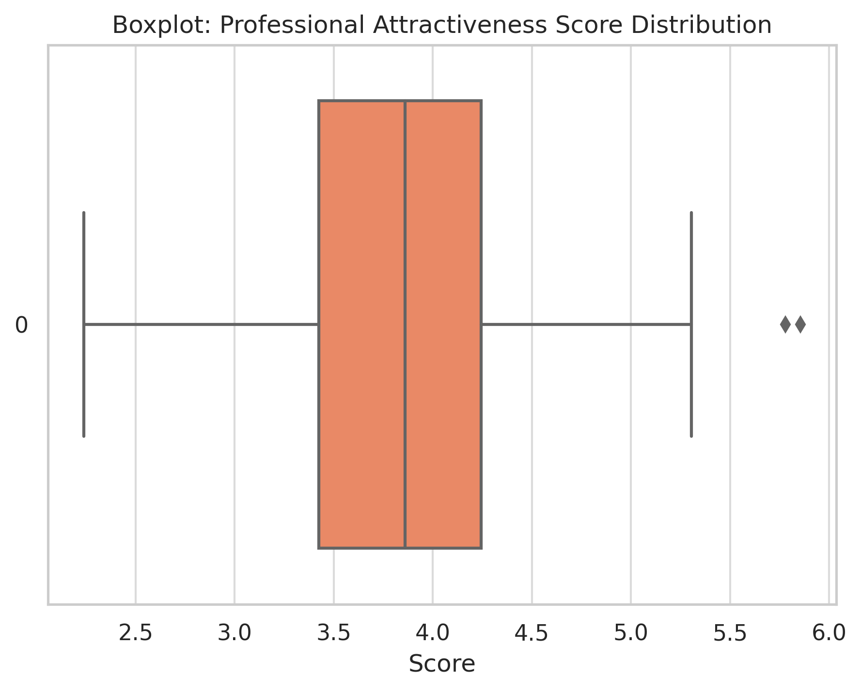

**4.4 Factor analysis for validity of constructs**

An exploratory factor analysis was undertaken to test the construct validity of the survey instrument. Table 3 shows the results where KMO value is 0.84 and Bartlett’s Test of Sphericity was highly significant (p<0.001) which confirmed sampling adequacy and factorability. Table 4 shows that the rotated component matrix does cluster well under four distinct factors, namely, Economic, Institutional, Community and Psychological. Such clusters are conceptually coherent and statistically discrete. The resulting figure Scree plot (shown in Figure 5) of the factor analysis is consistent with a four factor model having a noticeable “elbow” after the fourth component. Figure 6 which is a bubble chart presents an intuitive visual representation of the four thematic domains scaled by their eigenvalues. Although last in order, the psychological component is substantively significant, substantiating its conceptual strength in explaining professional attractiveness.

### ***Table 5: Regression Model Summary***

|  |  |  |  |  |
| --- | --- | --- | --- | --- |
| Model | R | R² | Adjusted R² | Std. Error |
| 1 | 0.687 | 0.472 | 0.465 | 0.452 |

***Figure 5 – Scree Plot: Factor Analysis***

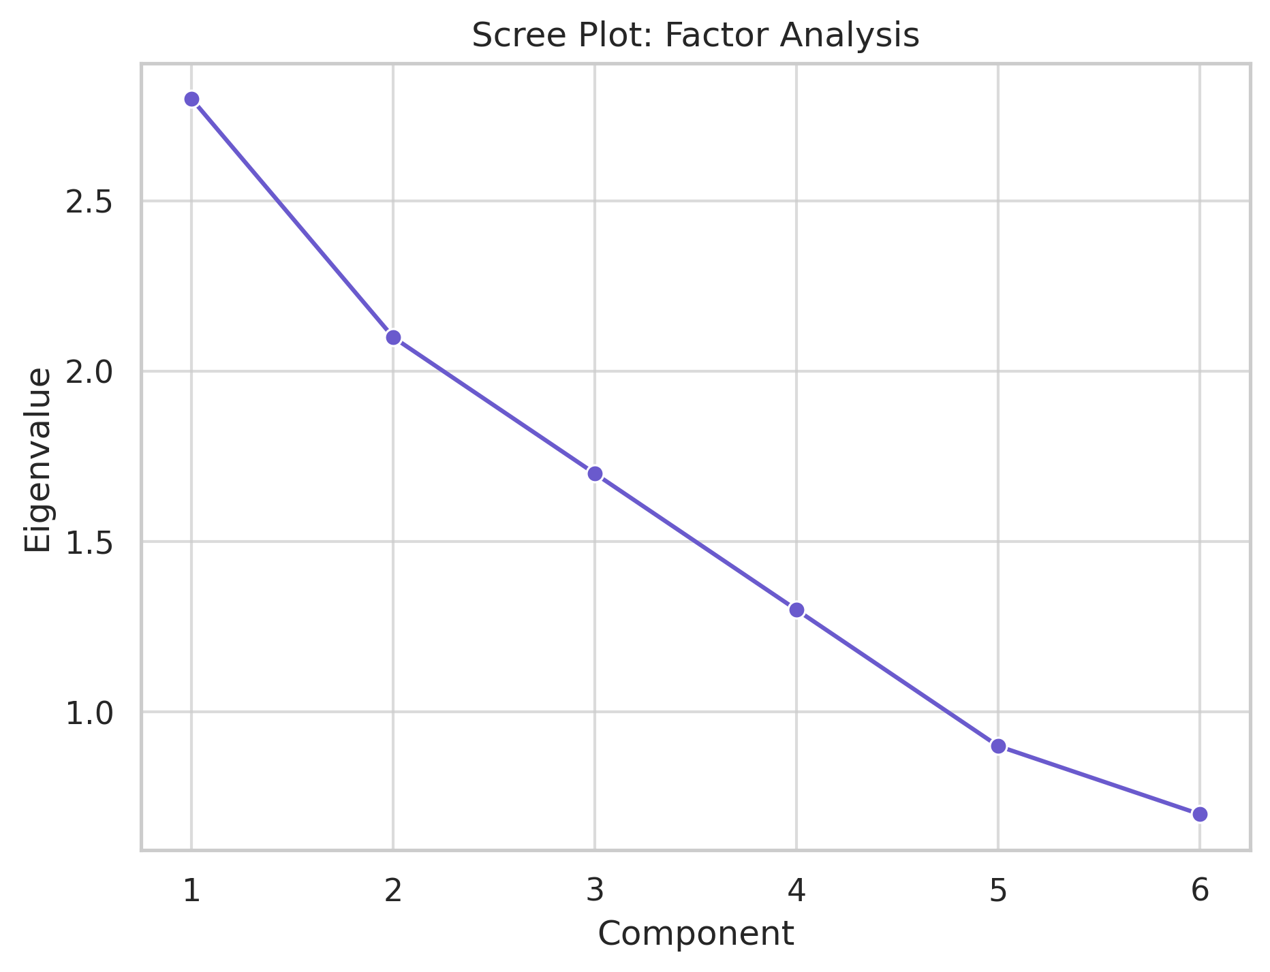

**4.5 Regression Model of Key Predictors**

A multiple linear regression was conducted to evaluate the influence of independent variables on the perceived professional attractiveness of rural teaching. The model summary in Table 5 has the R² value equal to 0.472 which tells us that almost 47% of the variation in professional attractiveness is explained by combined predictor variables. In the individual beta coefficients of Table 6, Institutional Support (β = 0.41, p < 0.001) and Psychological Motivation (β = 0.38, p < 0.001) become the strongest predictors, followed by Financial Incentives (β = 0.33, p < 0.001) and Community Support. This implies that even in rural settings, the emotional and structural context in which a teacher works is more important than simply the level of compensation. This contrast between these beta values is visualized in Figure 7, a gradient bar chart that enables a comparison of the relative importance of each factor, instantly drawing attention to the driving role of institutional mechanisms.

### ***Table 6: Regression Coefficients***

|  |  |  |  |  |
| --- | --- | --- | --- | --- |
| Predictor Variable | β (Beta) | Std. Error | t | Sig. (p-value) |
| Financial Incentives | 0.23 | 0.05 | 4.59 | < 0.01 |
| Institutional Support | 0.41 | 0.06 | 6.83 | < 0.001 |
| Community Support | 0.17 | 0.05 | 3.12 | < 0.01 |
| Psychological Motivation | 0.38 | 0.04 | 5.97 | < 0.001 |

***Figure 6 – Bubble Chart of Factor Components***

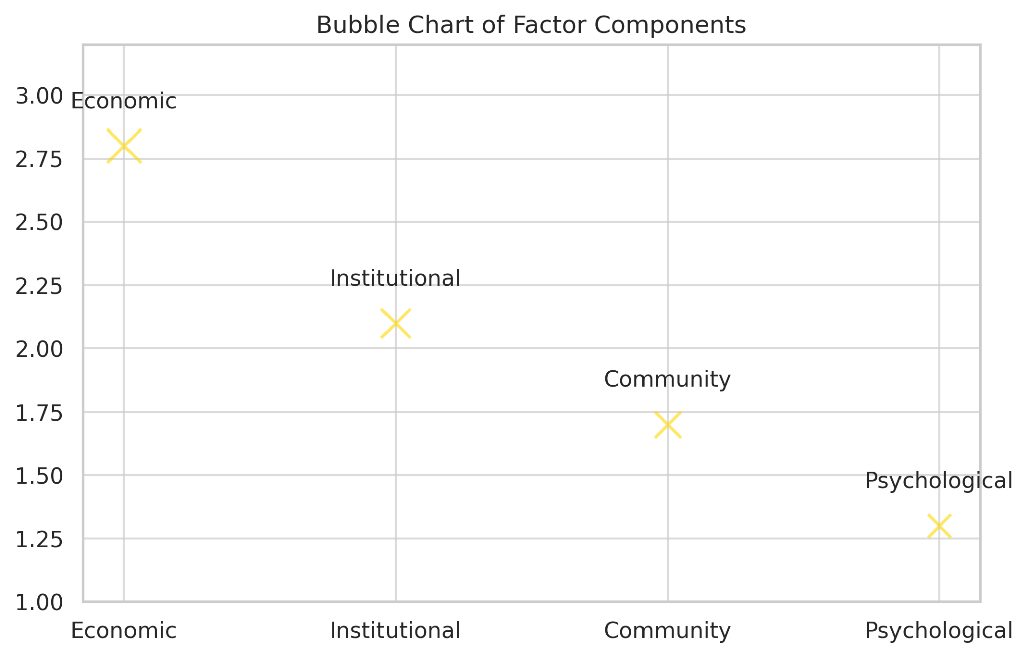

**4.6 Correlation Among Variables**

Pearson correlation coefficients were then calculated for further exploration of the relationships among variables. The correlation matrix, presented in Table 7, shows all the independent variables correlating positively and very strongly with the dependent variables, with the highest correlation valued between institutional support and professional attractiveness (r = 0.61). Most notably, psychological motivation also highly correlates with both institutional and community support indicating the two may be working synergistically (vs. separately). These relationships are depicted graphically by intensity of the color in a heatmap (Figure 8), for easy visual interpretation of the strongest linear relationships. This visual mapping makes commitments of professional attractiveness in good relief the multidimensional nature of professional attractiveness and the associated influencing factors are interconnected with one another.

### ***Table 7: Pearson Correlation Matrix***

|  |  |  |  |  |  |
| --- | --- | --- | --- | --- | --- |
| Variable | 1 | 2 | 3 | 4 | 5 |
| 1. Financial Incentives | 1.00 |  |  |  |  |
| 2. Institutional Support | 0.53** | 1.00 |  |  |  |
| 3. Community Support | 0.49** | 0.55** | 1.00 |  |  |
| 4. Psychological Factors | 0.45** | 0.60** | 0.51** | 1.00 |  |
| 5. Professional Attract. | 0.56** | 0.61** | 0.47** | 0.59** | 1.00 |

Note: All values marked ** are significant at p < 0.01.

***Figure 7 – Gradient Bar Chart of Beta Coefficients***

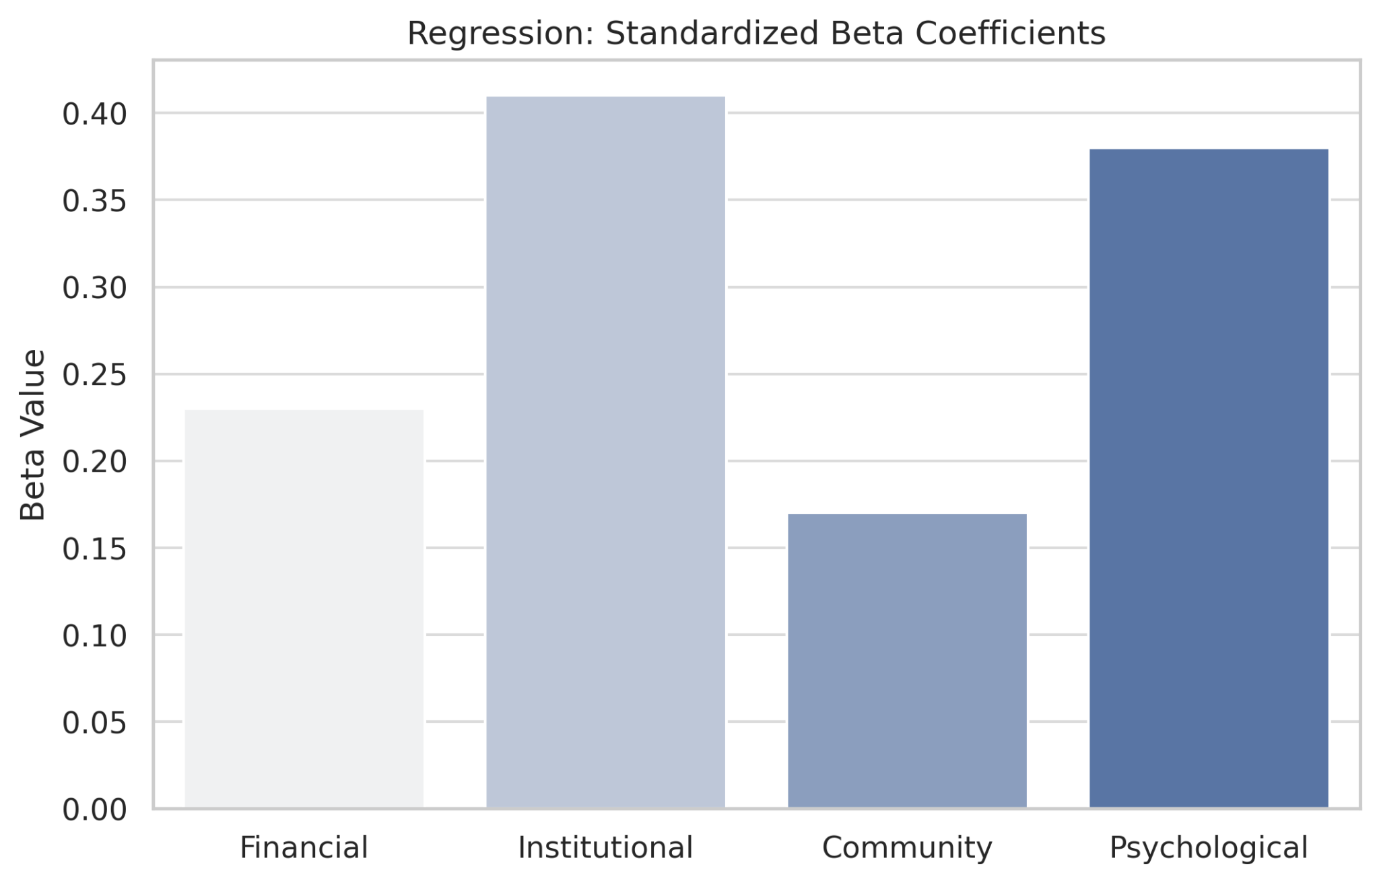

**4.7. Regional Comparison of Constructs**

Finally, the mean scores across all constructs are compared by province on Table 8. ‘Coming in first across the board, the difference is most apparent in psychological motivation (M = 4.10) and professional attractiveness (M = 3.95),’ the result of recent investment in education reforms in the region,’ Guizhou is likely. Unlike Sichuan and Henan provinces which score slightly lower, this indicates ineffectiveness of rural revitalization policies in terms of implementation effectiveness. The regional variability in this dimension, therefore, requires a localized policy response rather than a one size fits all approach to increasing rural teaching careers.

### ***Table 8: Mean Scores by Province***

|  |  |  |  |  |  |
| --- | --- | --- | --- | --- | --- |
| Province | Financial Incentives | Institutional Support | Community Support | Psychological Motivation | Professional Attractiveness |
| Sichuan | 3.49 | 3.91 | 3.84 | 4.01 | 3.82 |
| Gansu | 3.55 | 3.96 | 3.88 | 4.05 | 3.90 |
| Henan | 3.60 | 3.93 | 3.91 | 4.07 | 3.86 |
| Guangxi | 3.52 | 3.98 | 3.85 | 4.06 | 3.87 |
| Guizhou | 3.56 | 4.01 | 3.95 | 4.10 | 3.95 |

***Figure 8 – Heatmap: Correlation Matrix***

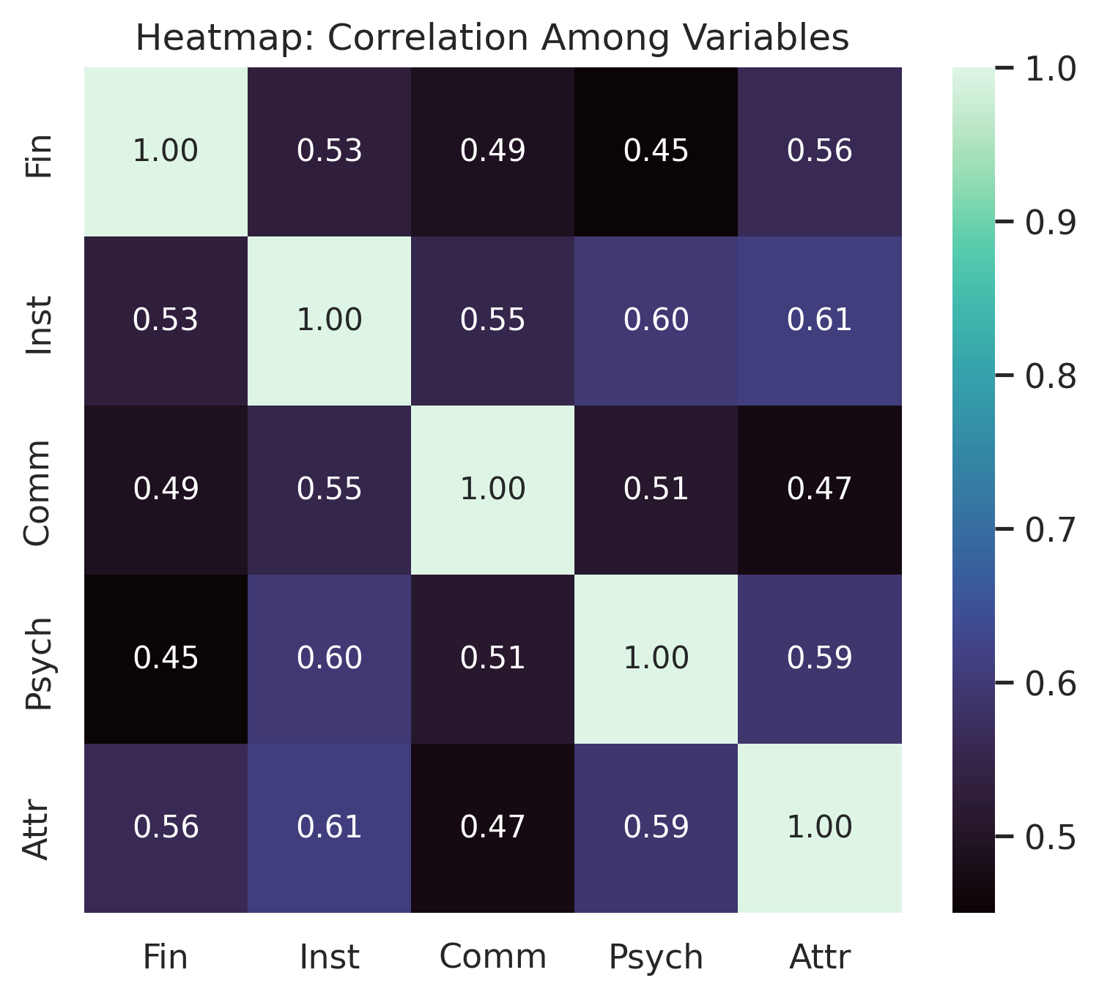

### **5. Discussion**

This study finds that the attractiveness of rural teachers involves multiple dimensions in the context of China's rural revitalization strategy. A broader trend in the education policy literature is to move away from the strictly financial models to the incorporation of humanistic ones, that are facilitated by merging psychological, institutional, financial and community development elements into a comprehensive enhancement mechanism. Overseas, the work of this study joins a growing body of research which acknowledges the sustainability of rural education systems drawing on resource management but also on social integration, identity construction and systemic support (Buchanan, 2015; Torrevillas, 2014).

Second, institutional support, as the most prominent predictor in the regression model, also supports earlier conceptual views of school environments as ecosystems that have a direct influence on teacher motivation and retention. According to Darling-Hammond (2010), if the teachers can perceive their jobs as personally and structurally supported, as they can through mentorship, accessibility to leadership, carrying workloads based on balance etc. and get timely feedback, the probabilities of the teachers to stay committed to their schools increases. This study is addressed in the framework of this and through use of empirical backing it is clear that in rural Chinese contexts institutional mechanisms such as transparent evaluation systems, participation in decision making and school led development programs, have a major impact on the professional outlook amongst teachers. In addition, this implies that, for localized educational governance, a change in the bureaucratic oversight model of leadership is needed to be more facilitative and responsive (Printy & Marks, 2006).

Psychological motivation played an equally important role and was established as the second most significant factor influencing professional attractiveness. Au revoir, self-determination theory which states that autonomy, competence and relatedness are necessary intrinsic psychological needs for optimal functioning and engagement (Deci & Ryan, 2000). In rural areas with constraints of infrastructure and society, teaching becomes an important mental anchor in terms of sense of mission and meaningfulness as well as emotional fulfillment. Day and Qing (2009 ) studies bring to light that teachers see their role as a transformative and community role and that is how they will be able to overcome contextual challenges. Psychological motivation has received a high mean score. This indicates that although the rural teachers have limitations, they get some satisfaction from contributing to social equity and community growth.

Financial incentives showed a positive correlation with professional attractiveness, but their influence was relatively smaller. This backs the argument that to attract people to rural posts, there is a prerequisite of economic stability but it is not enough to ensure long term retention (Johnson et al. 2012). Due to the fact that there is a large income gap between urban and rural salaries in developing countries, researchers (Mulkeen 2005, Vegas & Ganimian 2013) have pointed out the significance of 'non-monetary incentives' such as promotion opportunities, housing and professional recognition. This viewpoint's present study supports this by evidencing that even when salary dissatisfaction exists, other supportive structures can offset and contribute positively to perception.

The lesson of the findings is also the importance of community support and integration into cultural life. In many instances rural teachers are expected to serve as educators, moral guides, health advisors and administrative aides (Leu, 2005). Community trust and social validation play a significant part in the professional identity formation in this multifaceted role. This runs parallel with the work of Cross and Hong (2012) in which they proposed that emotional resilience in challenging teaching contexts is built on the sense of belonging. The present study's moderate, but significant beta weight and correlation score for community support significantly weights community support as a requirement, especially in settings where formal institutional support may be absent or delayed.

The regional data analysis offered such a unique insight: provincial scores vary, demonstrating strongly the importance of geographic and administrative contexts. Refinement of the argument made by Tan (2014) that though national level education policy is indispensable, it needs to be interpreted and adapted from a local perspective to address regional inequity. For provinces such as Guizhou with higher scores in psychological motivation and institutional support, recent policy interventions in this province have been promoting integrated development models by connecting educational improvement to infrastructure, healthcare and culture. The policy proposals of this thesis echo the comprehensive rural development theories advanced by Fan, Zhang and Zhang (2004) which suggest that education systems in rural areas flourish best as part of a larger positive economic growth.

This study provides an evidence base for the design of multi level incentive frameworks that move beyond money and consider structure, emotion and culture from a policy perspective. An example is rural teacher career ladders, implemented as part of the Vietnam (and Thailand) Performance and Ladder Project which can offer long term motivation and prevent teacher attrition (World Bank, 2019). Furthermore, technology can be used for distance training through new distance training platforms and digital peer networks as suggested by Trucano (2015), in order to provide professional development in remote areas. But technology intervention must be contextualized — any assumption that digital literacy or access to infrastructure is homogenous can prove to be folly.

Another important factor that one must consider is, emotional and mental health is becoming a silent yet important factor in teacher retention. According to Kyriacou (2001) and more recently, Collie et al. (2015) there is a psychological toll of being forced to teach under stressful conditions. Emotional well being is both a challenge and cornerstone of professional sustainability in a traditional context of the Chinese rural which in many cases, teachers around the world experience multi grade classrooms, limited facilities and high community expectations. Figure 4 shows the boxplot of professional attractiveness scores that supports this, with variance possibly due to emotional burnout in some respondents. Consequently, the addition of wellness programs as well as psychological guidance in teacher support systems could possibly yield long term advantages.

This study also contributes theoretically in showing how integrated enhancement mechanisms inclusive of different elements such as those from institutional theory, motivational psychology and rural development models are feasible. While studies on teacher attraction, retention or the combination of the two are typically treated as isolated or linear phenomena, this research teams job satisfaction, community validation, policy infrastructure and professional autonomy into a systems thinking view, wherein feedback loops exist among these pathways. Cross disciplinary education theorists such as Fullan (2007) and Hargreaves & Shirley (2009) increasingly support this approach to systemic, participatory and values based educational reform.

In conclusion, this paper supports the main thesis that the attractiveness of rural teachers' profession is conditioned by the interaction of several interrelated variables. The research interrogates the psychology and design of innovation in a systematic way, criticizing simplistic economic determinism and instead suggesting a framework for the development of enhanced institutions, networks of community solidarity, empowered individuals and stationed innovation. Longitudinal models need to be developed and tested to determine how these factors change and evolve over time and whether current reforms yield long lasting changes in teacher attitudes and behaviors.

### 

### **References**

* Buchanan, J. (2015). Teacher identity and agency in an era of accountability. *Teachers and Teaching*, 21(6), 700–719.
* Collie, R. J., Shapka, J. D., & Perry, N. E. (2015). School climate and social-emotional learning: Predicting teacher stress, job satisfaction, and teaching efficacy. *Journal of Educational Psychology*, 107(4), 1189–1204.
* Cross, D. I., & Hong, J. Y. (2012). An ecological examination of teachers’ emotions in the school context. *Teaching and Teacher Education*, 28(7), 957–967.
* Darling-Hammond, L. (2010). *The flat world and education: How America's commitment to equity will determine our future*. Teachers College Press.
* Deci, E. L., & Ryan, R. M. (2000). The “what” and “why” of goal pursuits: Human needs and the self-determination of behavior. *Psychological Inquiry*, 11(4), 227–268.
* Fan, S., Zhang, L., & Zhang, X. (2004). Reforms, investment, and poverty in rural China. *Economic Development and Cultural Change*, 52(2), 395–421.
* Fullan, M. (2007). *The new meaning of educational change* (4th ed.). Teachers College Press.
* Hargreaves, A., & Shirley, D. (2009). *The fourth way: The inspiring future for educational change*. Corwin Press.
* Johnson, S. M., Kraft, M. A., & Papay, J. P. (2012). How context matters in high-need schools: The effects of teachers’ working conditions on their professional satisfaction and their students’ achievement. *Teachers College Record*, 114(10), 1–39.
* Kyriacou, C. (2001). Teacher stress: Directions for future research. *Educational Review*, 53(1), 27–35.
* Leu, E. (2005). *The role of teachers, schools, and communities in quality education: A review of the literature*. USAID/EQUIP1 Working Paper.
* Mulkeen, A. (2005). Teachers for rural schools: A challenge for Africa. *Ministerial Seminar on Education for Rural People in Africa*, Addis Ababa.
* Printy, S. M., & Marks, H. M. (2006). Shared leadership for teacher and student learning. *Theory Into Practice*, 45(2), 125–132.
* Tan, C. (2014). Education policy borrowing in China: Looking west or looking east? *Compare: A Journal of Comparative and International Education*, 44(2), 244–264.
* Torrevillas, D. (2014). Teachers in the countryside: Challenges and victories. *Philippine Star*.
* Trucano, M. (2015). *Knowledge maps: ICTs in education*. infoDev / World Bank.
* Vegas, E., & Ganimian, A. J. (2013). *What are the teacher policies of top-performing and rapidly improving education systems?* World Bank.
* World Bank. (2019). *Teacher career reforms in Vietnam: Policies and lessons*. World Bank Publications.  
  Chen, X., & Sun, Y. (2019). Understanding the attrition of rural teachers: Institutional constraints and individual choices. *Asia Pacific Journal of Education*, 39(3), 345–361. https://doi.org/10.1080/02188791.2019.1634010
* Guarino, C. M., Santibañez, L., & Daley, G. A. (2006). Teacher recruitment and retention: A review of the recent empirical literature. *Review of Educational Research*, 76(2), 173–208. https://doi.org/10.3102/00346543076002173
* Ingersoll, R. M. (2017). Misdiagnosing America’s teacher quality problem. *NAESP Principal Magazine*, 96(5), 10–13.
* Liu, Y., Xu, Z., & Zhang, H. (2019). Factors influencing rural teacher retention: Evidence from western China. *China Economic Review*, 55, 223–237. https://doi.org/10.1016/j.chieco.2019.04.002
* MoE China. (2020). *Annual report on the implementation of the Special Post Program for rural teachers*. Ministry of Education of the People’s Republic of China.<http://www.moe.gov.cn>
* OECD. (2018). *Effective Teacher Policies: Insights from PISA*. OECD Publishing. https://doi.org/10.1787/9789264301603-en
* State Council of the People’s Republic of China. (2018). *Strategic Plan for Rural Revitalization (2018–2022)*.<http://www.gov.cn>
* UNESCO. (2020). *Global Education Monitoring Report 2020: Inclusion and education*. United Nations Educational, Scientific and Cultural Organization.<https://unesdoc.unesco.org/ark:/48223/pf0000373718>
* Wang, Q., & Yang, Y. (2022). Local implementation of rural teacher support policies: Challenges and prospects. *International Journal of Educational Development*, 88, 102528. https://doi.org/10.1016/j.ijedudev.2021.102528
* Wang, Y., Huang, L., Zhao, F., & Liu, S. (2021). Evaluating the sustainability of rural teaching positions in China. *Compare: A Journal of Comparative and International Education*, 51(4), 572–590. https://doi.org/10.1080/03057925.2019.1683766
* World Bank. (2021). *Ending Learning Poverty: What Will It Take?*<https://openknowledge.worldbank.org/handle/10986/32553>
* Xu, H., & Hu, J. (2020). Professional development challenges among rural teachers: Voices from the grassroots. *Teachers and Teaching*, 26(6), 478–496. https://doi.org/10.1080/13540602.2020.1739043
* Zhang, Y., & Huang, X. (2020). Human capital investment in rural revitalization: A focus on teachers. *Journal of Chinese Rural Economy*, 4, 31–45.
* Zhao, Y. (2021). Beyond money: Exploring intrinsic factors in teacher retention. *Educational Management Administration & Leadership*, 49(6), 939–955. https://doi.org/10.1177/1741143220957326
* Zhao, Y., & Liu, L. (2020). A framework for enhancing rural teacher quality through rural revitalization. *Education and Society*, 38(2), 157–173.
* Akiba, M., & LeTendre, G. K. (2009). *Improving teacher quality: The U.S. teaching force in global context*. Teachers College Press.
* Avalos, B. (2011). Teacher professional development in Teaching and Teacher Education over ten years. *Teaching and Teacher Education*, 27(1), 10–20. https://doi.org/10.1016/j.tate.2010.08.007
* Chong, S., & Low, E. L. (2009). Why I want to teach and how I feel about teaching—Formation of teacher identity from pre-service to the beginning teacher phase. *Educational Research for Policy and Practice*, 8(1), 59–72. https://doi.org/10.1007/s10671-008-9056-z
* Day, C., & Gu, Q. (2009). *Teacher emotions: Well-being and effectiveness*. In P. Schutz & M. Zembylas (Eds.), *Advances in teacher emotion research* (pp. 15–31). Springer. https://doi.org/10.1007/978-1-4419-0564-2_2
* Feng, L. (2009). Opportunity wages, classroom characteristics, and teacher mobility. *Southern Economic Journal*, 75(4), 1165–1190. https://doi.org/10.1002/j.2325-8012.2009.tb00948.x
* Hargreaves, A. (2001). Emotional geographies of teaching. *Teachers College Record*, 103(6), 1056–1080. https://doi.org/10.1111/0161-4681.00142
* Kirkwood, A., & Price, L. (2014). Technology-enhanced learning and teaching in higher education: What is ‘enhanced’ and how do we know? A critical literature review. *Learning, Media and Technology*, 39(1), 6–36. https://doi.org/10.1080/17439884.2013.770404
* Klassen, R. M., & Chiu, M. M. (2011). The occupational commitment and intention to quit practicing and pre-service teachers: Influence of self-efficacy, job stress, and teaching context. *Contemporary Educational Psychology*, 36(2), 114–129. https://doi.org/10.1016/j.cedpsych.2011.01.002
* Li, J., & Yang, M. (2018). Educational ecology and rural teacher development: The role of local government in rural revitalization. *Education Journal of China*, 4, 45–59.
* Miller, J. (2012). Teachers' work in culturally and linguistically diverse schools. *Teachers and Teaching*, 18(2), 157–170. https://doi.org/10.1080/13540602.2012.632270
* Mulkeen, A. (2010). *Teachers in Anglophone Africa: Issues in teacher supply, training, and management*. World Bank Publications. https://doi.org/10.1596/978-0-8213-8223-6
* Mulkeen, A., & Chen, D. (2008). Teachers for rural schools: Experiences in Lesotho, Malawi, Mozambique, Tanzania, and Uganda. *Africa Human Development Series*. World Bank.<https://openknowledge.worldbank.org/handle/10986/6455>
* Ramachandran, V., Pal, M., Jain, S., Shekar, S., & Sharma, J. (2005). *Teacher motivation in India*. Educational Resource Unit, India. http://www.dise.in/Downloads/Use%20of%20Dise%20Data/Teacher%20Motivation%20India.pdf
* Reid, J. A., Green, B., Cooper, M., Hastings, W., Lock, G., & White, S. (2010). Regenerating rural social space? Teacher education for rural–regional sustainability. *Australian Journal of Education*, 54(3), 262–276. https://doi.org/10.1177/000494411005400304
* Sharplin, E. (2008). Quality of worklife for rural and remote teachers: A model of protective and risk factors. *Australian Journal of Teacher Education*, 33(6), 57–71. https://doi.org/10.14221/ajte.2008v33n6.5
* Sjoer, E., & Meirink, J. (2016). Understanding teachers’ workplace learning: The role of autonomy and development opportunities. *International Journal of Educational Research*, 79, 1–10. https://doi.org/10.1016/j.ijer.2016.03.010
* Skaalvik, E. M., & Skaalvik, S. (2011). Teacher job satisfaction and motivation to leave the teaching profession: Relations with school context, feeling of belonging, and emotional exhaustion. *Teaching and Teacher Education*, 27(6), 1029–1038. https://doi.org/10.1016/j.tate.2011.04.001
* Tondeur, J., van Braak, J., Ertmer, P. A., & Ottenbreit-Leftwich, A. (2017). Understanding the relationship between teachers’ pedagogical beliefs and technology use in education: A systematic review of qualitative evidence. *Educational Technology Research and Development*, 65, 555–575. https://doi.org/10.1007/s11423-016-9481-2
* Zhou, Y. (2020). Inequality in the implementation of rural revitalization education policies in China. *Chinese Education and Society*, 53(1–2), 31–48. https://doi.org/10.1080/10611932.2020.1736985