Numerical simulation study on bed combustion of waste incinerator under high-altitude and low-pressure conditions

Hongze Zhang1,2,*

1Guangxi Key Laboratory of Machine Vision and Intelligent Control, Wuzhou University, Wuzhou, China

2School of Electronics and Information Engineering, Wuzhou University, Wuzhou, China

*\*corresponding author: hzzhang@mail.ustc.edu.cn*

***Abstract:*** *To optimize the layer combustion effect of the waste incinerator in the high-altitude and low-pressure region, the numerical simulation of a 350t/d waste incinerator in the high-altitude region of China was conducted based on the FLIC software. The simulation results show that the combustion process along the grate's moving direction can be roughly divided into three stages, which are the water evaporation stage from 0m to 8.9m, the volatile emission and combustion stage from 1.7m to 11.8m, and the fixed carbon gasification stage from 2.6m to the grate's outlet. The moisture content in the waste fuel is high, and the bed's thickness is significantly reduced after the moisture evaporation. Due to the low oxygen content in the air, it is necessary to increase the excess air ratio of the primary air. The gas phase temperature in the furnace is low, resulting in a low burnout rate of the fixed carbon. The primary air temperature can be increased to speed up the heating rate inside the waste combustion so that moisture and volatile components can be released more quickly. Changing the incinerator type from counter-flow to down-flow, increasing the grate area, and reducing the furnace's volume can improve the contact between the waste fuel and the oxygen, increase the gas-phase temperature of the furnace, enhance the radiation-induced combustion effect of the furnace and increase the combustion rate of the waste, thereby optimizing the combustion efficiency of the incinerator. Based on the simulation results, an optimization strategy is proposed for the operation and structure of the incinerator to achieve the purpose of optimizing combustion.*

***Keywords:*** *High altitude. Low pressure. Waste incinerator. Bed combustion. Numerical simulation.*

1. Introduction

With the rapid development of China's economy, the production of municipal solid waste (MSW) is increasing rapidly. Domestic waste contains harmful components to the human body. Without appropriate disposal, it will cause severe pollution to the environment. Currently, the primary way to deal with domestic waste in China is incineration because it can significantly reduce the weight and volume of waste, turn waste into inert residues with low environmental harm, and generate heat and electricity. It can realize domestic waste reduction, resource utilization, and harmlessness. Domestic waste in China has the characteristics of high moisture and ash [1]. With the improvement of people's quality of life, the calorific value of waste is rising [2].

The composition of waste is complex. In order to analyze the combustion process of the waste bed, Yang et al. [3-5] established a mathematical model of the bed combustion of the MSW and developed a two-dimensional simulation software of the bed combustion named FLIC (Fluid Dynamic Incinerator Code). Ma et al. [6] analyzed the effect of the primary air ratio on the combustion characteristics of the MSW incinerator. Qu [7] analyzed the gas phase's combustion characteristics of the waste incinerator under low-pressure conditions. Zhang et al. [8] studied the effect of the primary and secondary air supply ratio on the bed combustion of a waste incinerator in Lhasa. Lin et al. [9] simulated and analyzed the influence of the structure of a 350t/d waste incinerator on the combustion characteristics and flue gas distribution of the furnace. Yang et al. [10] conducted a simulation study on the co-combustion of the high calorific value industrial solid waste in a 500t/d waste incinerator. It was proposed that optimizing the angle of the secondary air is beneficial to the flue gas flow in the furnace. Based on a 450t/d waste incinerator, Zeng et al. [11] analyzed the combustion of the waste bed and the gas in the furnace under the condition of the variable mixing ratio of the stale waste and other variables.

Based on Yang's bed model, the FLIC software numerically simulates the bed combustion of a high-altitude waste incinerator. The combustion process of the waste bed is calculated and analyzed. The combustion parameters, such as the temperature distribution of the gas and solid of the waste bed, are obtained. The research results can provide a reference for the operation and structural optimization of waste incinerators in high-altitude regions.

1. Structure and fuel characteristics of the waste incinerator

The high-altitude grate waste incinerator has a treatment capacity of 350t/d. The incineration plant is in a high-altitude area, and the average oxygen in the air is only 64.3 % of the sea level. The main steam temperature of the incinerator is 400 °C, the main steam pressure is 4.0 MPa, and the furnace is counter-flow type. The schematic diagram of the incinerator is shown in Fig. 1. After the preheater preheats the primary air, it enters the furnace from the bottom of the grate with the primary air chambers. There is one row of secondary air jets on the front and the back walls.

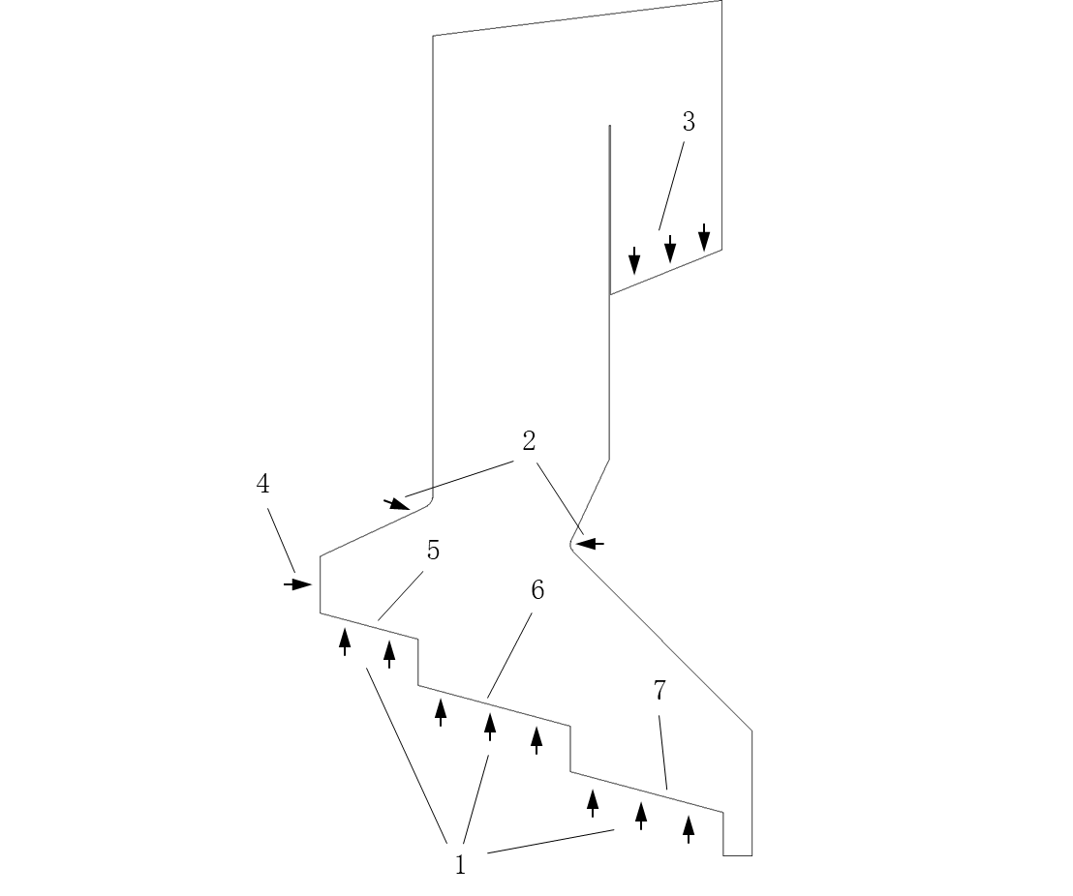

1. primary air. 2. secondary air. 3. flue gas. 4. waste fuel. 5. drying grate. 6. combustion grate. 7. burnout grate.

*Figure 1: The schematic diagram of the grate incinerator.*

Domestic waste is the incinerator's fuel. The ultimate and the proximate analysis of the MSW are shown in Table 1. The fuel's LHV is 7506 kJ/kg.

*Table 1: Ultimate and proximate analysis of MSW.*

|  |  |  |  |  |  |  |  |  |  |
| --- | --- | --- | --- | --- | --- | --- | --- | --- | --- |
| Ultimate analysis (as received)/% | | | | | | Proximate analysis (as received)/% | | | |
| C | H | O | N | S | Cl | M | V | FC | A |
| 20.69 | 2.42 | 9.43 | 0.52 | 0.05 | 0.39 | 45.26 | 25.38 | 8.12 | 21.24 |

1. Mathematical model of the bed combustion

The waste combustion on the moving grate is simulated with Yang's mathematical model [3]. Yang divides waste combustion on the grate into four processes: water evaporation, volatile release, gas-phase combustion of hydrocarbons, and gasification of carbon particles, which may overlap to some extent. The mathematical model of waste combustion is complex, and the main control equations for the gas and solid phases of the waste bed are proposed.

Gas-phase continuity equation:

 (1)

Gas-phase momentum equation:

 (2)

Gas-phase species transport equations:

 (3)

Gas-phase energy equation:

 (4)

Solid-phase continuity equation:

 (5)

Solid-phase momentum equation:

 (6)

Solid-phase species transport equation:

 (7)

Solid-phase energy equation:

 (8)

1. Numerical simulation of the bed combustion

# *Parameter setting of FLIC*

In the FLIC software, the parameters of the waste fuel, such as the proximate analysis, the ultimate analysis (dry-ash-free basis), the LHV, the number of the primary air chambers and the air distribution, the waste disposal capacity and the initial bed temperature needs to be input. The combustion parameters, such as the gas temperature distribution and the composition distribution at the top of the bed, can be obtained by solving the relevant control equations of the gas and solid phases in the combustion process. The results can be imported into Fluent as the boundary conditions of the upper calculation area of the bed.

FLIC divides the bed into several small units and discretizes the control equation for each unit. FLIC uses the SIMPLE algorithm to solve the control equations and the fourth-order Runge-Kutta algorithm to solve the radiation equations. In this paper, it is assumed that the volume composition of the volatile is CmHn (29.29%) and CO (70.71%), and the waste fuel is ignited by the furnace radiation. The fuel's particle size at the inlet of the bed is divided into five groups, which are 5cm×5cm×1 and 7cm×7cm×4. The shape factor of the fuel particles is 1.50. The bulk density of the fuel at the inlet of the bed is 501 kg/m3, the porosity is 0.63, and the bed's initial height is 835mm. The primary air volume is 1071.3 Nm3/min, the excess air ratio of the primary air is 2.02, the primary air temperature is 180 ºC, and the bed's moving speed is 8.47 m/h.

# *Simulation results*

The results of the combustion calculation are as follows: the water evaporation rate is 80.83%, the emission rate of the volatile is 59.69%, the combustion rate of the fixed carbon is only 12.33%, and the total mass loss of the fuel is 52.73%. Since the incinerator is under high-altitude and low-pressure conditions, the boiling point of water is 88.4 ºC, so the moisture of the waste fuel is quickly evaporated. Due to the low oxygen in the air, it is necessary to improve the excess air ratio of the primary air of the incinerator. Increasing the primary air volume improves the contact between the volatile and the fixed carbon in the waste fuel and the oxygen. The furnace temperature decreases accordingly. The emission rate of the volatile and the combustion rate of the fixed carbon in the waste fuel are limited, and the burnout rate of the waste fuel is not ideal.

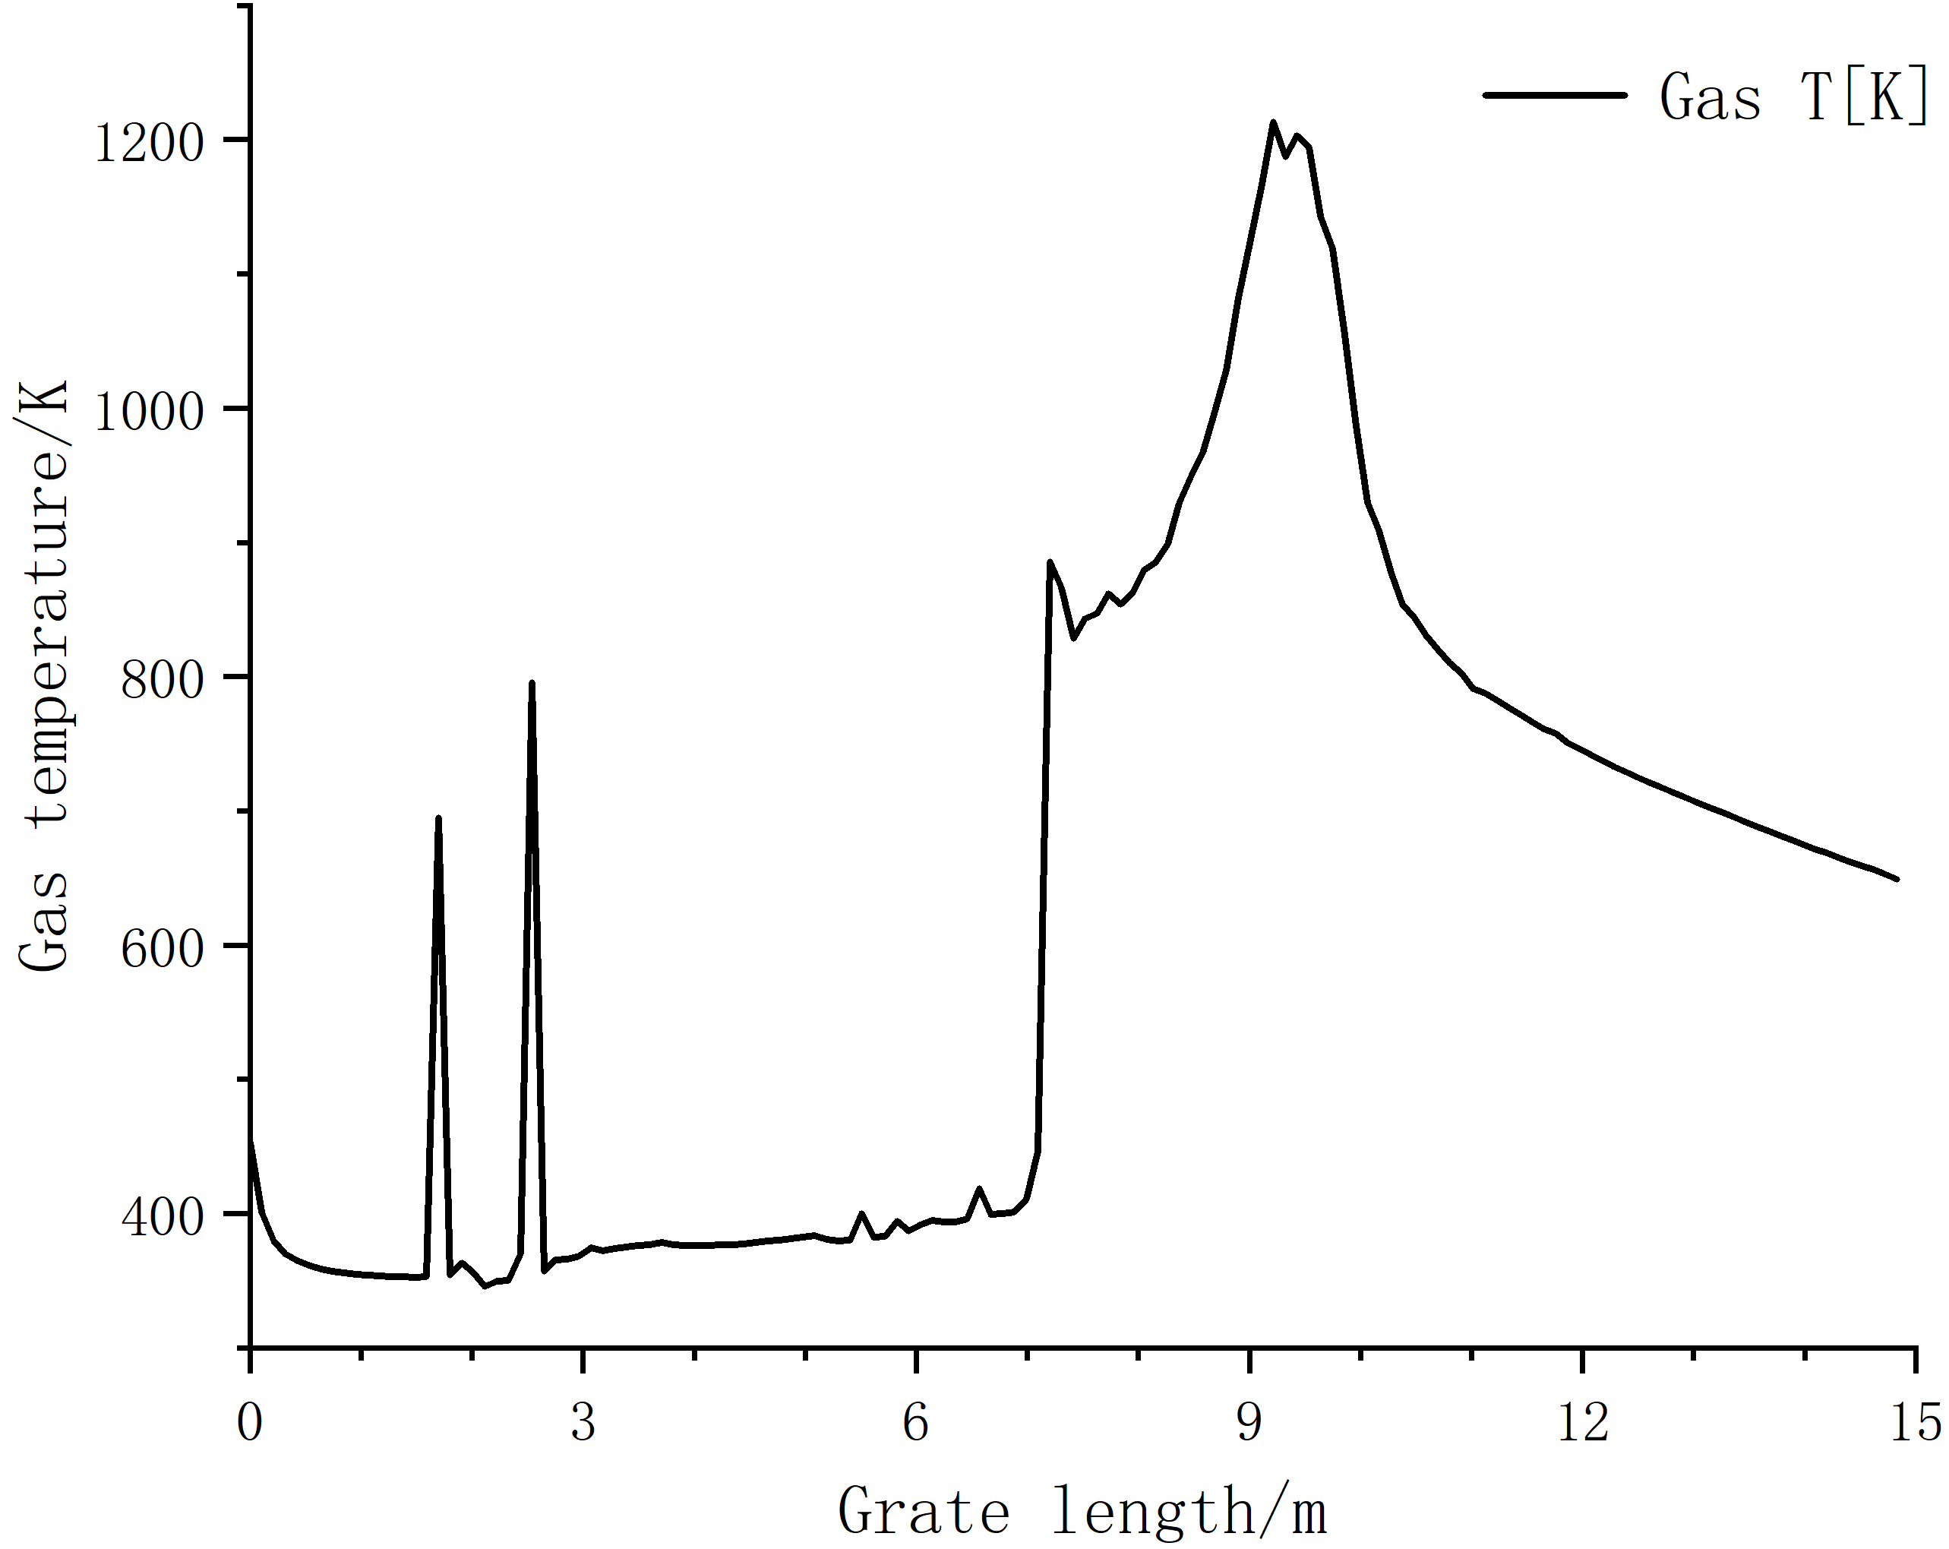

*Figure 2a: The temperature curve of flue gas.*

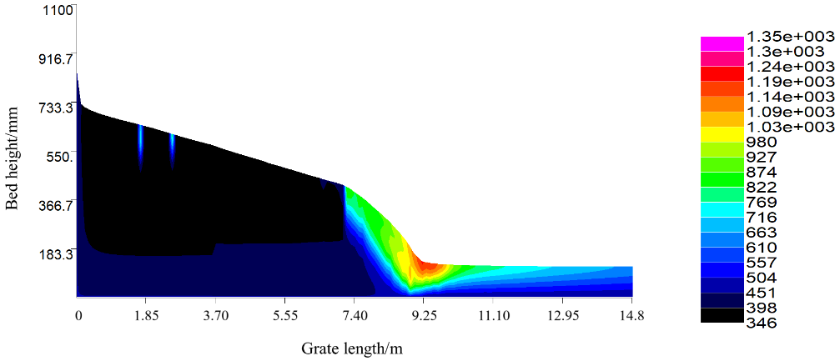

*Figure 2b: The temperature profile of flue gas(K).*

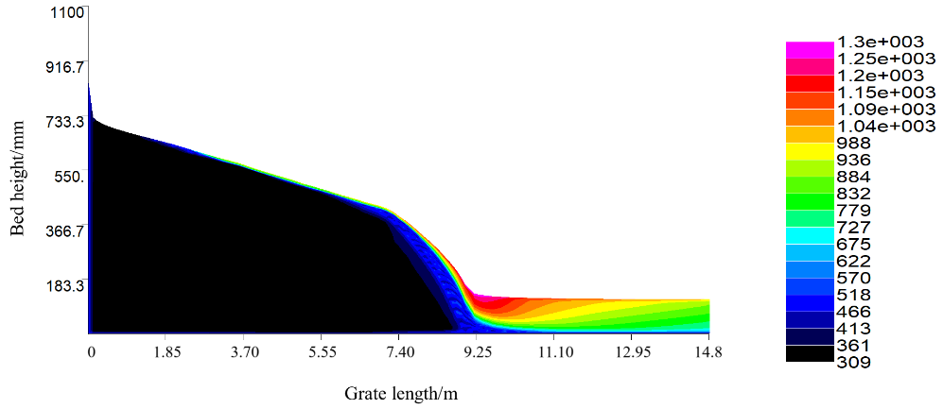

*Figure 3: The temperature profile of solid phase(K).*

Fig. 2 and Fig. 3 show the temperature distribution of gas and solid above the grate. Although the primary air temperature is 180 ºC and the furnace heats the waste fuel on the grate by radiation, the volatile is difficult to escape because the excess air ratio of the primary air is high and the furnace temperature is low. It can be seen from Fig. 2b that before 7.1m along the grate, the fuel's height decreased slowly, and the temperature change of the bed is not apparent, indicating that the fuel is in the dry stage, and the volatile is difficult to escape and burn. At 7.1m, the waste has passed through the dry section of the grate and reached the second half of the combustion section. After 7.1m, the volatile begins to escape and burn, the flue gas temperature above the bed rises rapidly, and the evaporation rate of the water in the fuel accelerates. Between 7.2m and 9.2m, the fuel is in the pyrolysis stage, and a large amount of volatile escapes and burns above the bed, and the bed's height decreases rapidly. As the fuel pyrolysis needs to absorb heat, the flue gas temperature above the bed gradually increases. After 7.2m, the volatile escaping from the fuel burns violently so that the temperature of the fuel on the grate gradually reaches the maximum temperature of 1302K. The gas at the top of the bed reached the maximum temperature of 1213K at 9.2m. After 9.2m, the volatile escape stops, the gas and the solid temperature begin to drop, and the fixed carbon in the fuel begins to burn rapidly. The fuel has passed through the grate's combustion section and is at the burnout section. Because the incinerator is the counter-flow type, the flue gas temperature in the burnout section is low. The ignition temperature of the fixed carbon is high, so it is hard to burn. The combustion rate of the fixed carbon is only 12.33%, resulting in a low burnout rate of the fuel.

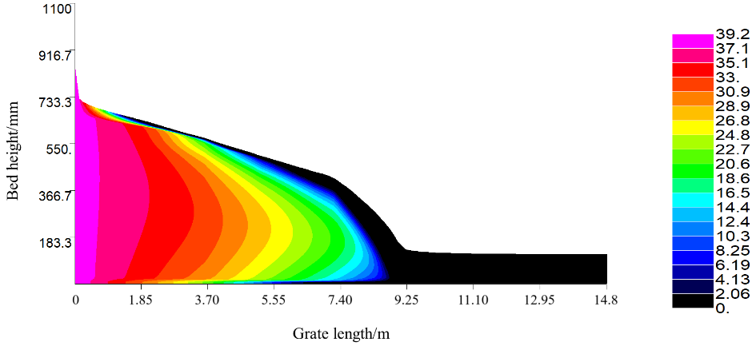

*(a) Mass fraction of the moisture.*

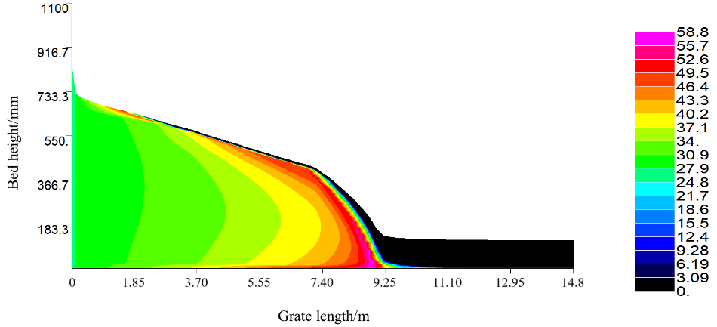

*(b) Mass fraction of the volatile.*

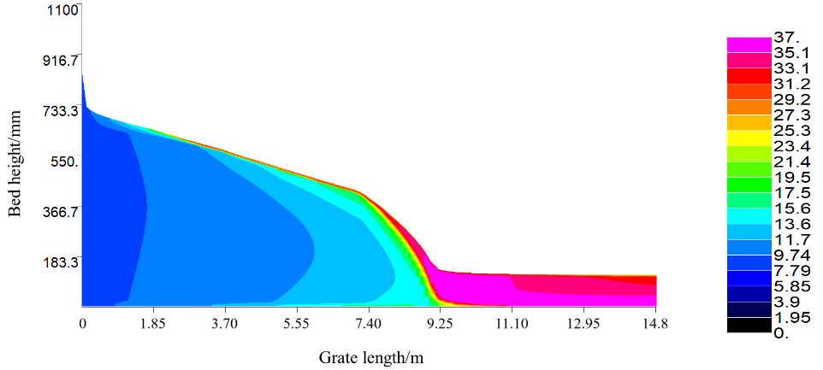

*(c) Mass fraction of the fixed carbon.*

*Figure 4: The mass fraction changes of composition contents.*

The mass fraction change of the fuel component is shown in Fig. 4, and the mass fraction change of the water is shown in Fig. 4(a). The water evaporates from the fuel with the radiation heat transfer in the bed's upper part and the convective heat transfer of the primary air at the bottom of the bed. It is distributed in a parabolic shape along the height of the bed. Fig. 4(b) shows the mass fraction change of the volatile. Compared with Fig. 3, when the surface temperature of the bed reaches 533K, the volatile in the fuel begins to escape and burn. Due to the water evaporation and the volatile escape, the bed's height decreases, and its volume shrinks. The mass fraction change of the fixed carbon is shown in Fig. 4(c). The ignition point of the fixed carbon is high, and its content remains stable in the initial stage of bed combustion. When the volatile escapes and burns violently, the flue gas temperature in the furnace is high. With the radiant heat transfer from the furnace to the bed and the combustion heat released from the bed, the fixed carbon begins to burn. In the waste combustion process, the mass fraction of the fixed carbon has two rapid change stages. In the first stage, the content of the fixed carbon increases from 8.12% to 37% when the volatile begins to escape. In the second stage, its content decreases from 37% to 33.9% from 8.8m to 10.9m along the grate's moving direction when it begins to burn.

Fig. 5 and Fig. 6 show the change rate of the components in the fuel and the mass fraction changes of the components in the flue gas along the moving direction of the grate. Due to the low boiling point of the water, it evaporates rapidly at the inlet of the furnace. The water absorbs heat during the evaporation, decreasing the gas-phase temperature, and its evaporation rate slows. From 7m, the bed temperature continues to rise. When the bed temperature rises to 533K, the volatile begins to escape. When the volatile begins to burn, the oxygen mass fraction decreases rapidly from 13% to around 0%, and the products of CO2 and H2O are generated. The combustion of the fixed carbon requires high temperature. At 8.8m, the surface temperature of the bed reaches 1028K, the fixed carbon begins to burn, and the product CO2 is generated. At 9.2m, the surface temperature of the bed reaches the maximum of 1213K, and the bed reaches the highest combustion rate. At 8.9m, the water evaporation ends, and the volatile combustion ends at 11.8m. Approaching the burnout grate, the fixed carbon starts to burn. Its combustion continues till the furnace outlet and the surface temperature of the bed drops to 648K at the furnace outlet. As shown in Fig. 5, when the volatile combustion ends, the fixed carbon continues to burn. The oxygen required for the waste combustion is few. Therefore, the oxygen mass fraction in the post-burnout section rises to 13.4%. Fig. 5 shows two peaks in the escape rate of the volatile. Due to the furnace's radiative heat transfer, the bed's surface temperature exceeds the volatile's escape temperature, and a large amount of the volatile escapes, resulting in the first peak. The volatile escape requires heat absorption, and the surface temperature has not been fully transferred to the bed's interior. Therefore, the escape rate of the volatile decreases. When the temperature inside the bed increases due to heat transfer, the volatile inside the bed escapes, resulting in the second peak. In this paper, it is assumed that the main components of the volatile are CmHn and CO, and they show the same escape rule in Fig. 6. As shown in Fig. 6, there are three peaks in the changes of the water mass fraction. The first peak is due to the effect of the radiation and the convective heat transfer on the fuel at the inlet of the furnace, and the water inside the fuel evaporates. The second peak is due to a small part of the volatile escaping from combustion, which promotes the evaporation of the water in the fuel. The third peak is due to the rapid evaporation of the water inside the fuel when the bed surface reaches the maximum temperature.

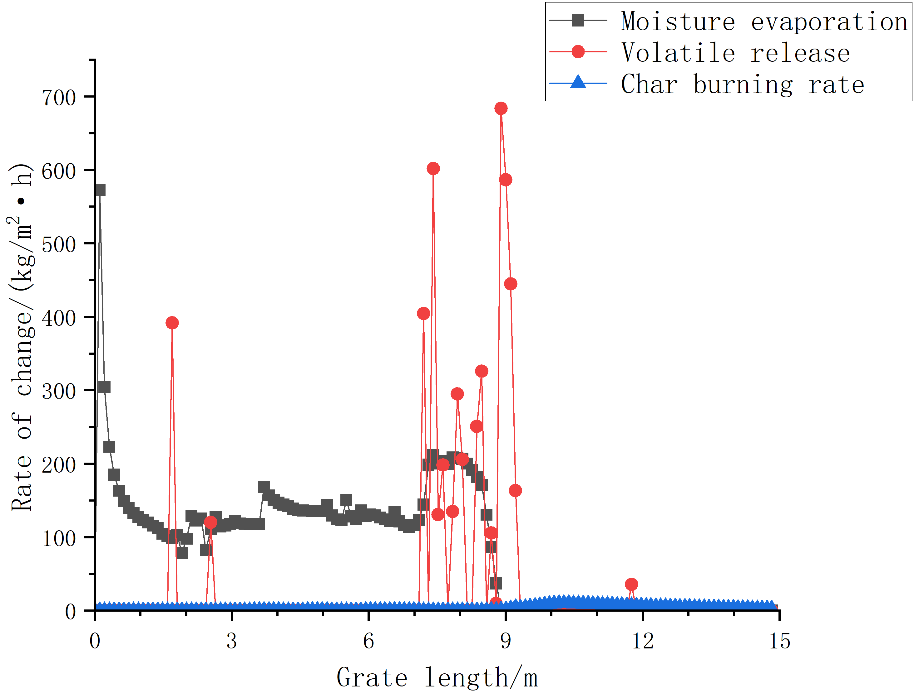

*Figure 5: The release rates of compositions.*

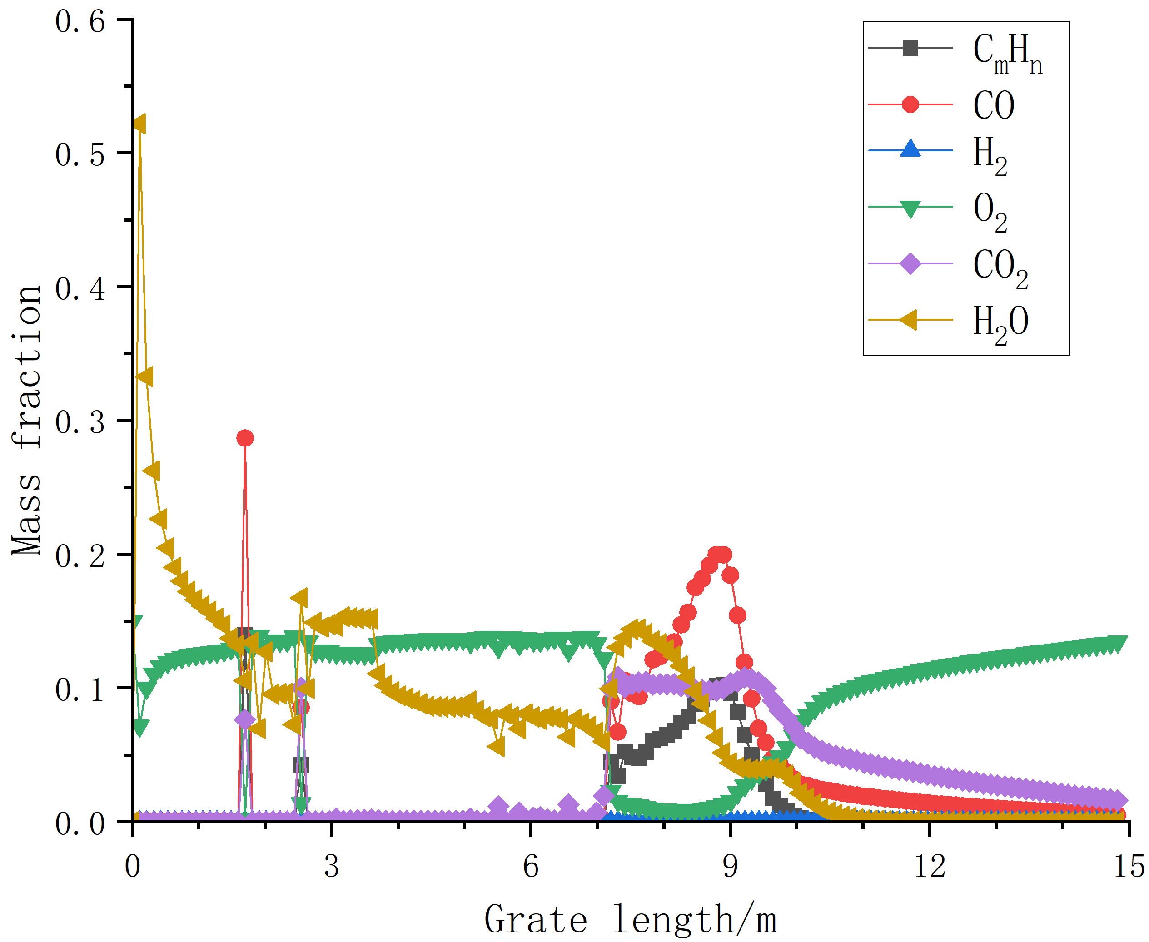

*Figure 6: The changes in mass fraction of flue gas.*

1. Operation optimization analysis

Because the incinerator is at the high-altitude and oxygen-depleted region, the fuel's burning rate is lower than the standard rate in the plain region, and the fuel is difficult to ignite and burn. The atmospheric pressure in the plateau region is low, and the oxygen content in the air is lower than that in the plain region. It is necessary to increase the primary air volume. It will reduce the furnace temperature, weaken the radiation heat transfer of the furnace to the waste bed, and reduce the radiation ignition effect on the fuel. Increasing the primary air temperature can enhance the convective heat transfer between the primary air and the bottom of the bed, improve the heating rate inside the fuel, and accelerate the escape rate of the moisture and the volatile in the fuel. Because the furnace temperature is relatively low, part of the incompletely burned flue gas will enter the flue for combustion, resulting in the temperature increase of the boiler outlet. In order to ensure the boiler's thermal efficiency, it is necessary to increase its convective heat exchange area. In order to improve the burnout rate of the waste, it is necessary to increase the grate area and strengthen the contact between the fuel and the oxygen. Changing the incinerator type from counter-flow to down-flow can improve the combustion effect of the fixed carbon in the burnout section, improving the overall burnout rate of the fuel. Reducing the furnace's volume can increase its temperature, enhance its radiative heat transfer, accelerate the evaporation rate of the water in the fuel and the escape rate of the volatile, and improve the combustion rate of the fuel.

1. Conclusions

In this paper, the numerical simulation of a high-altitude MSW grate incinerator in China is conducted. The temperature distribution of the gas and solid phases along the grate's moving direction is obtained. The variation rules of the fuel components and the main components of flue gas are acquired. The simulation results show that the combustion process of the waste bed can be divided into three stages: water evaporation, volatile emission and combustion, and fixed carbon gasification. According to the combustion characteristics of the high-altitude waste incinerator, increasing the primary air temperature can improve the heat transfer inside the fuel and the combustion efficiency of the waste. The furnace volume is suggested to be reduced to enhance its radiation intensity and accelerate the combustion process. Because of the low burnout rate of the fixed carbon caused by the low furnace temperature, the grate area is suggested to be increased to enhance the contact between the fuel and the oxygen to improve the burnout rate of the fixed carbon. The simulation results provide a reference for the operation and structure optimization of the waste incinerators in the high-altitude and low-pressure regions.

Acknowledgments

This work was financially supported by the National Natural Science Foundation of China (Grant NO. 51765060) and the Guangxi Science and Technology Major Project (Grant NO. AA18118036).

References

*[1] Xiaobo Wang, Anqi Liu, Huiqiong Zhong, et al.* *Characteristics of municipal solid waste in some urban agglomeration in the past five years [J]. Environmental Science, 2023, 44(11): 6421-6432.*

*[2] Yantao Wang, Yang Cao.* *Analysis on garbage caloric value in MSW incineration power plant in China [J].* *Environmental Sanitation Engineering, 2019, 27(05): 41-44.*

*[3] Yang Y B, Goh Y R, Zakaria R, et al. Mathematical modelling of MSW incineration on a travelling bed [J]. Waste Management, 2002, 22(4): 369-380.*

*[4] Yang Y B, Goodfellow J, Ward D, et al. Cutting wastes from municipal solid waste incinerator plants [J]. Process Safety and Environmental Protection, 2003, 81(B3): 143-155.*

*[5] Yang Y B, Yamauchi H, Nasserzadeh V, et al. Effects of fuel devolatilisation on the combustion of wood chips and incineration of simulated municipal solid wastes in a packed bed [J]. Fuel, 2003, 82(18): 2205-2221.*

*[6] Xiaoqian Ma, Guohui Liu, Zhaosheng Yu.* *Combustion optimization of municipal solid waste incinerator based on CFD [J].* *Journal of South China University of Technology (Natural Science Edition), 2008, (02): 101-106.*

*[7] Zhaozhou Qu.* *Numerical simulation of waste incinerator chamber under low atmospheric pressure with gas combustion [J].* *Environmental Sanitation Engineering, 2017, 25(05): 84-87.*

*[8] Zhichen Zhang, Hejiang Sun, Degang Ma.* *Simulation and optimization of combustion process of the MSW incinerator in Lhasa [J].* *Environmental Sanitation Engineering, 2023, 31(04): 35-40.*

*[9] Tao Lin, Yanfen Liao, Xucong Yan, et al. Structure optimization of 350t/d waste incinerator [J].* *Journal of South China University of Technology (Natural Science Edition), 2021, 49(07): 116-124.*

*[10] Xu Yang, Zhaosheng Yu, Yurong He, et al.* *Numerical simulation of municipal domestic waste blending with combustion of high calorific value industrial solid waste in waste incineration furnace [J].* *Clean Coal Technology, 2023, 29(09): 98-108.*

*[11] Wuqing Zeng, Yu Wang, Qingguo Bu, et al.* *Study of co-incineration characteristics of aged refuse and municipal solid waste [J].* *Journal of Huazhong University of Science and Technology (Natural Science Edition), 2025, 53(01): 107-113.*