**Design of real-time feedback system for physical education classroom under digital transformation**

Yanan Liu 1, Hongjie Liu2, *

1.General Graduate School, Dongshin University, Naju-si ,Jeollanam-do ,58245，Republic of Korea

2. School of Physical Education and Health,Linyi University, Linyi,Shandong ,27600, China

*e-mail：hongjieliu8888@163.com

Abstract:In the context of educational digital transformation, traditional physical education (PE) classrooms often face challenges such as delayed feedback, limited individualization, and inefficient data utilization. To address these issues, this study designs and implements a real-time feedback system tailored for PE instruction, integrating data collection, intelligent processing, visual feedback, and instructional optimization into a unified framework. The system architecture adopts a four-layer model—platform, core control, terminal, and data analysis—to ensure modular coordination and extensibility.The system enables real-time sensing through wearable devices, collects physiological and motion data, and processes these inputs using edge computing and visual analysis techniques. Feedback is delivered to students via multi-modal outputs including visual cues, voice prompts, and dashboard summaries, while teachers receive real-time diagnostic support and post-class reports. The student interface is designed for intuitive interaction, supporting engagement and self-correction during active movement sessions.A field experiment was conducted in three junior high school classes, involving over 90 students and multiple PE sessions. The results demonstrate the system's effectiveness: average feedback response times were under two seconds, and student satisfaction reached 84.3%, as shown in post-session surveys. Teachers also reported increased efficiency and decision-making accuracy during classroom instruction. However, challenges such as environmental signal interference and motion recognition errors under complex movements were identified, highlighting areas for future technical optimization.This study contributes to the integration of educational technology and intelligent feedback in physical education, offering a practical solution for real-time, data-driven teaching. The proposed system promotes timely interventions, improves learning engagement, and supports evidence-based instruction. Future work will focus on adaptive feedback personalization, scalability across diverse PE settings, and long-term impacts on student performance and motivation.

Keywords: digital transformation, physical education, real-time feedback, wearable sensing, instructional optimization, educational technology

**1. Introduction**

With the continuous advancement of information technology, digital transformation has become a crucial driving force for educational reform. In basic education, digital technologies are profoundly reshaping classroom organization, content delivery methods, and teacher-student interaction pathways. As a vital component of quality-oriented education, physical education classes have long been constrained by factors such as delayed feedback mechanisms, one-way teacher-student interactions, and insufficient personalized guidance[1]. In traditional PE classes, teachers often struggle to obtain real-time data on students' movement execution, physical performance, and classroom engagement. This results in subjective and non-targeted feedback that hinders continuous improvement in teaching effectiveness.

As a vital application in educational informatization, real-time feedback systems have been widely implemented in subjects like mathematics and English. Their teaching-assistance capabilities, based on real-time data collection and visual analysis, provide effective tools to enhance classroom efficiency and optimize instructional practices[2-3]. However, research and application of such systems in physical education remain in their infancy. Due to the open nature of PE classrooms, dynamic student movements, and complex data collection challenges, most existing systems struggle to meet the demands for real-time responsiveness, high precision, and interactive feedback[4]. Therefore, developing an integrated real-time feedback system tailored to PE classroom characteristics—featuring data acquisition, feedback generation, and teaching optimization functions—holds significant academic value and practical significance.

This study proposes an instant feedback system design for digital physical education classrooms, adopting a three-dimensional integration perspective of "technology-teaching behaviors-learning outcomes". The system integrates data acquisition modules (e.g., motion recognition and heart rate monitoring), feedback generation mechanisms (e.g., visual feedback and scoring systems), and teaching support terminals (e.g., teachers 'mobile devices and large-screen displays). Using a secondary school PE class as a case study, the system underwent experimental implementation and effectiveness evaluation. Through its deployment, the system not only enhanced teachers' ability to make timely and scientific instructional adjustments but also improved students' perception of physical performance and classroom engagement.

**2. Research methods and technical routes**

This study employs a systematic design methodology to develop an instant feedback system tailored for digital physical education classrooms. The research framework begins with needs analysis, leveraging modern information technology architecture to focus on four core components: "data collection, data processing, feedback generation, and instructional optimization". By integrating modular design principles, the system achieves functional integration and application optimization[5-6]. Developed using object-oriented design principles, the system utilizes wearable devices and teaching terminals in synergy to enable real-time classroom data perception and interactive feedback.

2.1 Technical architecture and module design

The system adopts a four-layer structure architecture of "platform layer, core system layer, terminal execution layer and data analysis layer" (see Figure 1).

The platform layer utilizes the school's digital education platform as its supporting environment, responsible for stable system deployment and permission management. The core system layer serves as the control center of this system, integrating command scheduling, module coordination, and resource allocation functions. The terminal execution layer includes teacher feedback devices (such as tablets), student wearable devices (like smart bracelets and motion capture trackers), and teaching display equipment (including large screens and projectors). The data analysis layer processes collected data through modeling, featuring modules like "Classroom Behavior Analysis", "Student Movement Analysis", and "Teaching Optimization Suggestions". These modules are interconnected via wireless networks, with internal data flows progressing from the perception layer to the processing layer before being transmitted back to teachers through feedback modules, enabling closed-loop control of teaching processes. The system interface design adheres to the principles of "simplicity, intuitiveness, and efficiency", ensuring teachers can quickly access system feedback in complex teaching scenarios to assist in instructional decision-making.

2.2 Data acquisition method

Data collection is the prerequisite for system operation, which is mainly carried out by the multi-mode sensing devices worn by students. According to the activity characteristics of physical education classes, the data collection content mainly includes [7-8]:

Physiological data: such as heart rate and body temperature, using Bluetooth heart rate belt and infrared temperature measuring device;

Motion data: such as the frequency, amplitude and rhythm of running, jumping and throwing, using three-axis accelerometer and gyroscope;

Location data: Determine the activity range of students through UWB positioning or camera video analysis;

Classroom behavior data: such as action completion rate and participation heat, which are automatically generated by image recognition and heat map algorithm.

The system is configured to collect data at 5-10 samples per second, ensuring immediate generation of initial feedback. All raw data is transmitted via encrypted wireless networks to the core system, where it undergoes cleaning and formatting before being analyzed in real-time by processing modules. The system also incorporates edge computing frameworks, enabling partial data preprocessing at terminal devices to reduce server workload.

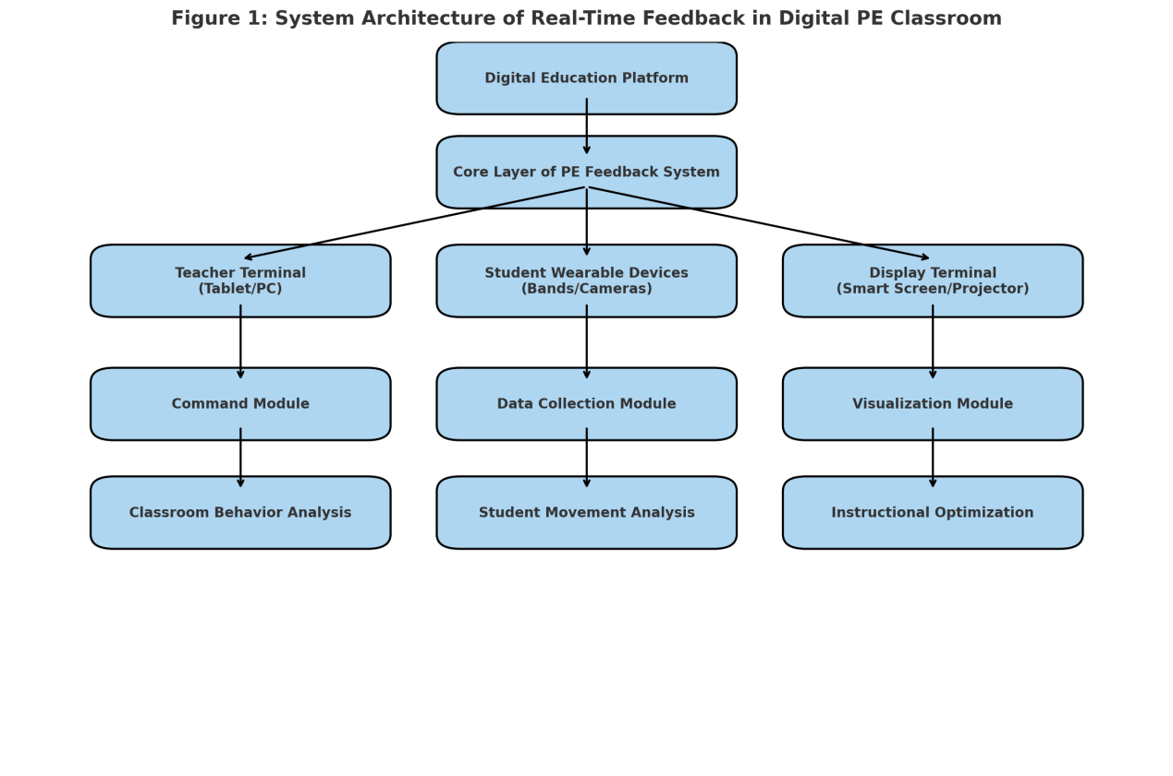

**Table 1**

**Step No.**

|  |  |  |
| --- | --- | --- |
| **Process Step** | **Function Description** | **Function Description** |
| Physical Activity in PE Class | Students perform physical activities during class | Students perform physical activities during class |
| 2 | Real-time Sensing (Wearable Devices) | Devices capture motion, heart rate, and posture data |
| 3 | Data Transmission (Wireless/Bluetooth) | Data is sent to the system via wireless protocols |
| 4 | Data Processing Module | Raw data is cleaned, analyzed and interpreted |
| 5 | Feedback Generation (Visual/Audio/Dashboard) | Feedback is displayed as scores, visuals or sounds |
| 6 | Teacher Adjustment and Instructional Optimization | Teachers use feedback to adjust teaching in real-time |

3. System design and implementation

Based on the principle of "task-driven + data-driven", this system adopts modular, configurable and responsive design strategy to deeply integrate key links and technical functions in physical education classroom, so as to ensure that the system has real-time, interactive and educational adaptability [9].

3.1 Function module design

Based on the principle of "task-driven + data-driven", this system adopts modular, configurable and responsive design strategy to deeply integrate key links and technical functions in physical education classroom, so as to ensure real-time, interactive and educational adaptability of the system.

3.1.1 Teacher terminal function

Teachers can access the backend through teaching tablets or laptops to monitor student data in real time, control feedback outputs, receive instructional suggestions, and generate course reports (see Table 2). The system provides multiple data visualization methods (graphics, charts, metrics) to help teachers quickly understand students' physical performance and engagement levels[10-12].

3.1.2 Student interactive interface

After students wear the device, they can get feedback information through wristband, electronic screen or voice prompt. The interactive interface module has graphical representation, voice broadcast, autonomous click feedback and other functions to meet the perceptual needs of students of different ages (see Table 3).

3.1.3 Real-time feedback mechanism

The feedback mechanism is the core part of the system. Through the system setting threshold and behavior recognition algorithm, different types of feedback can be triggered, such as color prompt, vibration reminder, voice broadcast, graphic warning and other forms (see Table 4). The feedback mechanism supports both automatic triggering and manual sending by teachers.

3.2 Information visualization and interaction strategy

In the design of the system, teachers 'operation efficiency and students' perceptual ability are fully considered to build a multi-level visual interaction system:

Teacher-end interaction strategy: Utilizes card layouts with visual comparisons, supporting filtering by time, project, and student. Real-time data charts (e.g., line graphs, radar charts) enable instant decision-making. Student-end interaction strategy: Transmits physical movement through color gradients and animations, delivering concise, intuitive feedback. Feedback output format: Multi-modal integration like "red icons + voice prompts + score updates" enhances accuracy and acceptance. Visual presentation hierarchy: The system supports three display dimensions: real-time data (live scenes), periodic data (per-class), and cumulative data (semester summaries), meeting diverse teaching evaluation needs.

Table 2

|  |  |
| --- | --- |
| **Module** | **Function Description** |
| Real-time Monitoring | Display student activity data in real-time (e.g., heart rate, movement) |
| Student Performance Overview | Aggregate performance data by student or class |
| Feedback Control | Trigger individual or group feedback mechanisms |
| Teaching Recommendations | Generate suggestions based on class engagement and performance |
| Class Report Export | Export summary reports for teaching reflection and assessment |

Table 3

|  |  |
| --- | --- |
| Interface Element | Function Description |
| Motion Indicator | Displays movement status using icon colors or meters |
| Visual Feedback Prompt | Pop-up visuals when action is correct/incorrect |
| Voice Prompt | Audio prompts indicating errors or encouragement |
| Performance Dashboard | Shows cumulative scores and exercise stats |
| Interaction Button | Used for active response, confirmation or self-assessment |

Table 4

|  |  |  |
| --- | --- | --- |
| Feedback Type | Description | Application Scenario |
| Visual | Uses colors, icons or animations for instant perception | In dynamic movement tasks (e.g., sprint, jump) |
| Auditory | Voice or sound alerts triggered by data thresholds | In high noise environments or for fast-paced guidance |
| Textual | Short phrases displayed on screen (e.g., ‘Try Again’) | For students with visual impairments or younger students |
| Data Dashboard | Graphical summary of student performance data | For teachers to view patterns and trends after class |

4. System test and application effect evaluation

In order to verify the feasibility and effectiveness of the digital sports classroom real-time feedback system in real teaching situations, this study selected three classes from a middle school in a city to carry out system testing, and carried out quantitative and qualitative evaluation on feedback response speed, student satisfaction and classroom participation performance respectively, so as to comprehensively judge the practical application value of the system.

4.1 Experimental Settings (e.g., physical education test in a school)

In order to verify the feasibility and effectiveness of the constructed digital sports classroom real-time feedback system in real teaching situations, this study selected three classes in a middle school in a city to carry out system testing, and conducted quantitative and qualitative evaluation on feedback response speed, student satisfaction and classroom participation performance respectively, so as to comprehensively judge the practical application value of the system[13].

4.2 Data collection (teaching satisfaction, student performance, feedback response time)

This study focuses on the collection of data for three key indicators:

(1) Feedback Response Time: The average duration from detecting abnormal behavior to generating feedback reflects the system's real-time responsiveness and technical stability. Data is automatically recorded in backend logs, as shown in Figure 6. Results indicate that Class A and C maintain stable average response times between 1.5-1.7 seconds, while Class B shows significantly slower performance, which may be related to on-site equipment layout or network environment factors.

(2) Teaching Satisfaction: A self-designed questionnaire was used to assess students' subjective perceptions regarding system operation experience, feedback effectiveness, and usage interest. A total of 96 questionnaires were distributed with a 100% response rate. As shown in Figure 7, the proportion of "very satisfied" and "satisfied" responses reached 84.3%, indicating that the majority of students maintained a positive attitude toward the system.

(3) Classroom Performance and Participation: By combining the system-generated classroom scoring records with teachers 'observational feedback, this study evaluated students' exercise completion quality, frequency of active interaction, and classroom concentration. The data showed that after the system intervention, students' average scores increased by 12.6%, and the ratio of active questioning to feedback actions significantly improved.

4.3 Effectiveness analysis

The overall performance of the system in field teaching is good, which verifies the feasibility of its design objectives:

The feedback mechanism operates efficiently with a response time under 2 seconds, meeting the essential "real-time" feedback requirements for physical education classes. Students demonstrate high acceptance, as diversified feedback formats (visual/auditory) enhance engagement and participation. The system's teaching support value is significant, enabling teachers to identify instructional gaps more precisely through real-time data analysis and implement personalized adjustments.

However, this round of testing also exposed some shortcomings, such as some devices still have misjudgment in motion recognition, signal interference occasionally occurs in outdoor environment and other problems. In the future, we will optimize hardware compatibility and data processing fault tolerance mechanism.

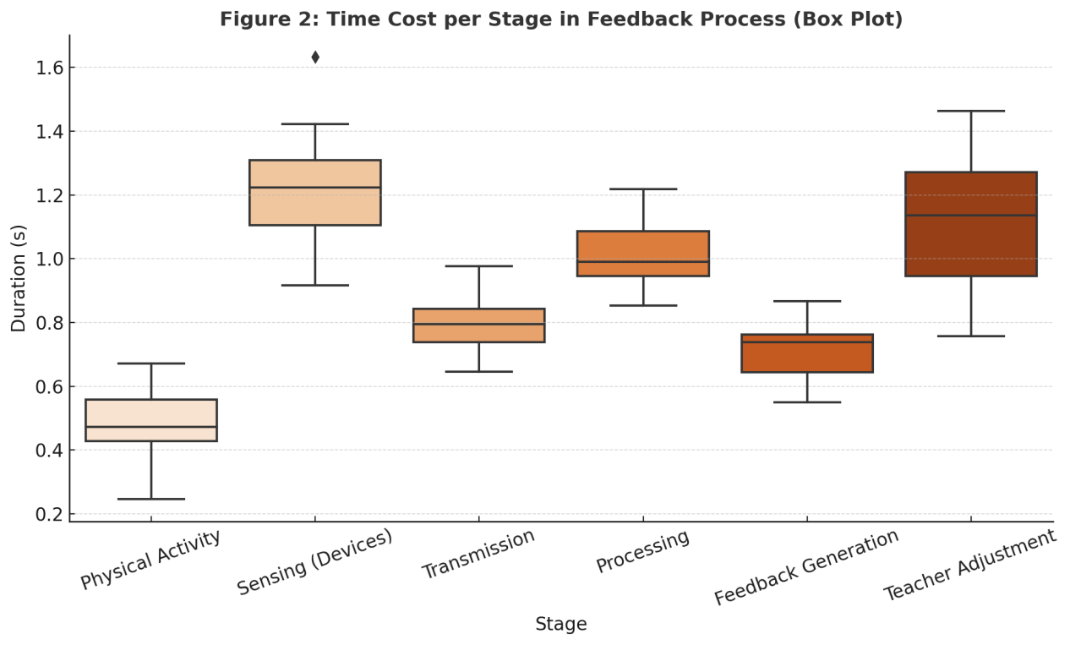

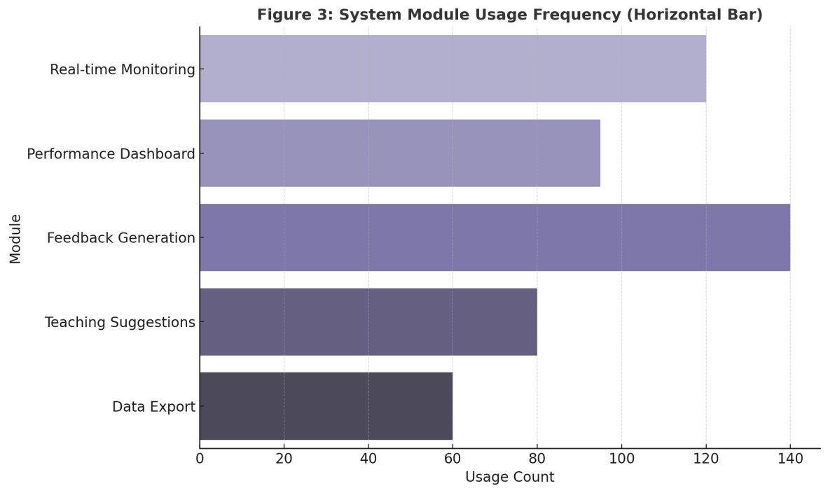**5. Discussion and conclusion**

This study addresses critical challenges in digital transformation within physical education classrooms, including delayed feedback, insufficient personalization, and low data utilization rates. We developed an integrated real-time feedback system combining "data collection, real-time feedback, and teaching decision support". Through technical architecture design, functional module development, field application testing, and quantitative analysis, the system has demonstrated significant improvements in enhancing classroom interaction efficiency and feedback timeliness.

From a system architecture perspective, the four-tier framework (Platform Layer, Core Layer, Terminal Layer, Analysis Layer) proposed in this study not only decouples and coordinates module functionalities but also provides robust support for future system scalability. Key modules such as real-time monitoring for teachers, visual feedback systems for students, automated data processing, and instructional suggestion delivery cover critical components of physical education classroom workflows, enabling rapid closed-loop integration between teaching practices and learning outcomes. Field testing results demonstrate the system's strong adaptability in data accuracy, instant feedback delivery, and user acceptance. Average response times for student feedback are kept under 2 seconds, with the system promptly providing individual movement quality assessments to educators for timely corrections. Satisfaction surveys show over 84% of responses rated "satisfied" or higher, indicating widespread recognition of the system's practical value and user-friendliness. Teacher evaluations highlight that the visual interface and scoring mechanism enhance teaching management efficiency and scientific rigor. However, several areas require optimization: signal fluctuations in outdoor sports field environments may affect data transmission, while equipment still exhibits measurement errors during extreme motion capture. Additionally, differences in perception preferences between age groups regarding feedback formats (e.g., voice versus icons) suggest the need for deeper system adaptation development in personalized feedback and multimodal sensing capabilities.

Theoretically, this study effectively integrates educational technology and artificial intelligence perception mechanisms with physical education classroom scenarios, expanding the research boundaries of data-driven teaching practices in sports education. Unlike traditional teaching models that rely on teachers' experiential judgments, this system utilizes real-time data to enhance the objectivity, immediacy, and precision of classroom feedback and instructional interventions, providing an actionable practical paradigm for intelligent sports education[14-15].

In conclusion, the real-time feedback system developed in this study demonstrates promising potential for implementation in physical education classrooms, effectively enhancing classroom interaction efficiency and instructional feedback quality. Future research could expand its application to multiple grade levels and teaching scenarios by integrating artificial intelligence recognition algorithms, edge computing, and learning analytics models, thereby driving the evolution of physical education toward "intelligent, precise, and personalized" directions. Additionally, it is crucial to focus on improving teachers' professional competencies and providing systematic training for system utilization, ensuring the continuous integration and practical effectiveness of technology into educational processes.

**6. References**

[1] Xu Y, Peng J, Jing F, [1] Xu Y, Peng J, Jing F, et al. From wearables to performance: how acceptance of IoT devices influences physical education results in college students. Scientific Reports, 2024, 14: 23776.

[2] Martín-Rodríguez A, García-Hermoso A, López-Gil J F, et al. Technology-Enhanced Pedagogy in Physical Education. Education Sciences, 2025, 15(4): 409.

[3] Zhang Zeyu, Rittisom S, Hongseanyatham P. Utilizing wearable technology to enhance physical education teaching in Chinese high schools. International Journal of Sociologies and Anthropologies Science Reviews, 2025, 5(3): 77–86.

[4] Mukul E, Jones M, Smith L. Digital transformation in education: a systematic review of Education 4.0 literature. Current Opinion in Psychology, 2023, 49: 101595.

[5] Gao X, Ruan J, Gao J, [5] Gao X, Ruan J, Gao J, et al. From motion signals to insights: a unified framework for student behavior analysis and feedback in physical education classes. arXiv preprint, 2025.

[6] Ahn D, Lim H. Exploring K–12 physical education teachers' perspectives on opportunities and challenges of AI integration through ideation workshops. arXiv preprint, 2025.

[7] Widhalm K, Steiner T, Bucher D, [7] Widhalm K, Steiner T, Bucher D, et al. Real-time digitized visual feedback in exercise therapy: user recommendations for prototype feedback visualizations. Journal of Rehabilitation and Assistive Technologies Engineering, 2024, 11: 20556683241235703.

[8] Hu Z, Zhao L, Tang Y, [8] Hu Z, Zhao L, Tang Y, et al. AI-driven smart transformation in physical education. Applied Sciences, 2024, 14(22): 10616.

[9] Cui Z.[9] Cui Z. Innovating physical education with artificial intelligence. Frontiers in Psychology, 2025, 16: 1490966.

[10] Zhang C, Li T, Ma Y. The mechanism and realization path of digitalization in physical education at Shenzhen University. Open Journal of Social Sciences, 2025, 13(4): 31–39.

[11] Chen X, Liu Y, Zhang R. Effectiveness of wearable activity trackers on physical activity: a meta-analytic review. BMC Public Health, 2025, 25(1): 157.

[12] Priante A, López-Meneses E, Rivera-Rogel D. Integrating technology in physical classrooms: the impact of game-based student response systems. Journal of Educational Technology & Society, 2025, 28(1): 14–25.

[13] Milanko S, Hernández-Leo D, Rodríguez-Triana M J. Designing just-in-time detection for gamified fitness frameworks. arXiv preprint, 2020.

[14] Zhang Z, Rittisom S, Hongseanyatham P. Utilizing wearable technology to enhance physical education teaching in Chinese high schools. International Journal of Sociologies and Anthropologies Science Reviews, 2025, 5(3): 77–86.

[15] Mulato N, Purnama Y, Setiawan R. Optimization of learning physical education in digital era: a systematic review. International Journal of Instruction, 2024, 17(1): 89–102.