**Algorithmic Management Dilemma: The Double-Edged Sword Effect on Employee Well-Being and Task Performance**

Shili Luo

School of Economics and Management，Sichuan Agricultural University, Mianyang, 621000, Sichuan Province, China.

[v455921738@163.com](mailto:v455921738@163.com)

### **Abstract**

An algorithmic management (AM) has emerged in the rapidly changing arena of digital workplaces, representing a transformative — and controversial — concept. Using a survey with 312 respondents from a variety of industries where work is allocated, monitored and evaluated using algorithmic systems, this study examines the double edge sword of AM impact on employee well-being and task performance. The study shows that while AM significantly increases task performance (measured by higher efficiency and consistency; better real time feedback), it significantly but negatively affects employee well being (higher psychological stress, perceived surveillance and autonomy loss). The mediating role of perceived autonomy in the relationship between AM and well-being is further confirmed by the mediation analysis and it reveals its crucial role in human systems interaction. This is a paradox: algorithmic tools that are built for performance optimization can cause emotional exhaustion and alienation when implemented without human-centered defenses. This study enlarges the ongoing discussion of digital labor, AI machine work systems and workers' resiliency and provides practical insights for ethical design and regulation of AM technology. The need is for an 'and': the harmony of automation and empathy to guarantee that the primal essence of human experience in work is not digested by the efficiency of technology.

**Keywords:** Algorithmic Management, Employee Well-Being, Task Performance, Autonomy, Digital Labor, Surveillance, AI in HR, Ethical Design, Workplace Automation, Technostress

### **1. Introduction**

Rather than an exception, algorithmic management (AM) has become a force transforming how work is organized, supervised and evaluated in the digitizing landscape of work. The term Algorithmic Management (AM) was coined by Lee at al. (2015, p. 645) as the use of algorithms and data driven technologies to coordinate and manage human labor (see also Keeling, 2019) and has been adopted widely across industries, from the gig economy platforms such as Uber and Deliveroo (Newlands, 2021), to formal corporate environments, for example in logistics, retail and customer support (Kellogg et al., 2020). Algorithmic management essentially substitutes or augments these functions: task allocation, performance evaluation and behavioral oversight by automated, algorithmic decision making systems that operate in real time (Mateescu & Nguyen, 2019). While it promises increased efficiency, scalability and objectivity, it also presents unique ethical and psychological challenges associated with employee well being and autonomy.

But the growing literature on algorithmic management has begun to take stock of the ways in which algorithmic management implies new parameters of the human experience of work. As Möhlmann et al. (2021) point out, algorithmic systems that can drive improved fairness and consistency are 'black boxes' that offer little transparency or recourse to the employees they govern. Workers may lose agency if the actions on workload, breaks or performance ratings are taken without being dictated by human dialogue or contextual knowledge (Ivanova et al., 2018). But as output increases or task performance improves measured by this method, the stress can increase, job satisfaction and burnout can also increase (Tarafdar et al., 2019; Wood et al., 2019). Such a contradictory outcome is the underlying concept of the algorithmic management dilemma—a concept suggesting a dual effect: the performance gain is accompanied with psychological costs.

Initial framings of algorithmic tools were within the realm of technological optimism because the tools could reduce managerial bias and increase productivity (Binns et al., 2018). In fact, algorithms are able to provide data rich feedback, predictive analytics and real time corrections that could theoretically optimize completion of the task and minimize inefficiencies (Jarrahi et al., 2021). For example, in warehouse settings algorithmic scheduling has reduced idle time and improved throughput (Rosenblat & Stark, 2016). However, while the same systems might champion metrics and micro surveillance and continuous assessment they may threaten creativity, adaptability and emotional resilience (Veen et al., 2020). Particularly sharp are gig worker reports of feeling ‘trapped in metrics’, i.e., in the sense that all their actions are under surveillance and measured against opaque performance benchmarks (Moore, Upchurch, & Whittaker, 2018). The psychological consequences of these are consistent with the technostress framework (Tarafdar et al., 2019) that frames digital technologies as both an enabler as well as a stressor based on the extent of control exercised by the user, training and support systems associated with these technologies.

Concerns have also been raised in regards to the dehumanizing components of AM by scholars. Although traditional supervisors may be empathetic, judicious and make contextual judgments, algorithmic managers inflexibly and lacking emotional nuance impose rules (ParentRocheleau & Parker, 2021). Feedback and decision making without interaction with people erodes relational trust leading to feelings of alienation or depersonalized work (Kellogg et al., 2020). Additionally, employees are frequently left out of the design and iterative process for these systems and, as a result, are left powerless to participate in and bargain collectively (Galière, 2022). It adds to the ethics of digital labor rights, algorithm accountability and workplace fairness particularly in settings in which the workforce is already precarious.

As such, AM is a dual technical and socio-technical phenomenon and the discussion regarding its implications for STS theory resonates with broader debates regarding the nature of technological interventions and their direct instrumental and indirect socio-humanistic impacts (Trist & Bamforth, 1951). Rather, AM tools are not neutral, but rather form and are formed by the organizational environment (i.e., culture, labour relations and institutional frameworks) in which they are situated (Zuboff, 2019). An alternative lens to pursue this inquiry is similarly provided by the Job Demands-Resources (JD-R) model. According to Bakker and Demerouti (2007), job demands, e.g., surveillance and inflexible metrics, deplete energy and psychological resources; conversely job resources, like feedback and autonomy, enhance engagement and well being. Employee strain ensues and work satisfaction declines as the number of personal resources and work demands rises, but algorithmic management results in poor resource allocation.

These tensions need to be addressed and thus, we need to empirically gauge the effects of algorithmic management on task performance and employee well being. Despite the surge of a significant body of work that has focused either on performance gains or stress outcomes and within different employment contexts, a paucity of studies considers both performance gains and stress outcomes together. In order to address this gap, this study combines quantitative performance metrics with qualitative insights on worker experiences to analyze the double-edged sword effect of AM. The aim of doing so is to take part in the development of algorithmic governance frameworks that are balanced and ethical, while enabling productivity without compromising human dignity of labor.

### **2. Literature Review**

Algorithmic management (AM) is changing organizational hierarchies, labor processes and the psyche of labor. Management authority and decision making were traditionally resident in direct human supervision where judgment was discretionary and negotiated between people. In digitized workplaces though, where I will focus my analysis, many of these responsibilities have been de-politicized and shifted to algorithmic systems that draw upon big data, predictive analytics and real time monitoring; which then allocate tasks, assess performance and enforce compliance (Ajunwa, 2020). It is particularly deep in platform labor, including food delivery, ridesharing and freelance marketplaces and is now spreading deep into traditional corporate activities (Bajwa et al., 2021). Although this ambition towards greater efficiency and impartiality stands to bring advantages, the literature is increasing its documentation on the potentially harmful results that this evolution can have for the emotional, psychological and social well being of workers.

The opacity and perceived fairness of algorithmic systems are one of the key debates in the literature. Algorithms do not usually explain or have flexibility about context when enforcing decisions (Pasquale, 2015). Because algorithmic logic is of a “black box” nature, it creates a feeling of randomness and powerlessness for the workers, destroying the typical organizational trust (Eubanks, 2018). Angrave et al. (2016) have also focused on how opaque performance analytics make workers more anxious, outraged and less satisfied with their jobs when they are not allowed to understand or influence their opaque metrics. The result of this produces what O'Neill (2016) calls 'weapons of math destruction', utilizing flawed or biased data to facilitate unfair outcomes that are at a high level hard to refute.

Furthermore, literature has demonstrated that algorithmic control increases work intensification and emotional labor to unsustainable degrees. According to Fleming (2017), algorithmic management replicates a kind of ‘digital Taylorism’: the minutia of an employee’s work becomes monitored and quantified and overseen in real time. In this condition, workers are expected (although unwillingly) to carry out the performative labor, described by Diefenbach and Sillince (2011), as working tirelessly to optimise 'visibility' and 'productivity', regardless of the loss of authenticity and health. Leighton (2019) documents, for example, how Amazon warehouse employees were pushed by algorithmic weights to forgo bathroom breaks, to downplay injuries and to stay in an escalated state of productivity at the expense of burnout and attrition.

On the other hand, algorithmic systems also provide opportunities to reduce bias and standardize. In one vein of research, AM tools can decrease favoritism and discrimination by ensuring uniformity by utilizing well designed AM tools to enforce uniform rules and performance standards (Binns, 2019). For example, algorithms used in HR analytics can increase diversity by reducing unconscious bias during candidate, evaluation and resume screening, according to Kim (2017). But even these benefits rely on knowing that these systems are trained with data that is transparent and fair. However, if the training data contain past inequalities or discriminatory hiring patterns, the algorithm will replicate and perfect these patterns, as reported by Noble (2018) in his study on algorithms bias in digital platforms.

The literature in the domain of employee autonomy takes a nuanced view. However, other scholars contend that, far from diminishing agency, AM forces conformity to rigid behavioral scripts (Scholz, 2017); and yet still other scholars argue that algorithmic tools can enhance autonomy in specific settings. Boudreau and Lakhani (2013) describe how task automation and data driven scheduling can let complete mundane decisions, freeing up employees to focus on their strategic or creative work. But the benefit of AM is often only afforded to higher skilled professionals and low wage or precarious workers benefit from AM as a mechanism of control. Turn to Dubai (2020), who notes the contrast between the experience of gig drivers, on the one hand, with remote software engineers, on the other, who both work under algorithmic systems but in significantly different ways.

Recent studies concerning algorithmic governance have also investigated the psychological aspect of worker relations with the employer in terms of psychological contract. Workers' understandings about the reciprocal obligations that they believe exist between themselves and their organization are denoted in the psychological contract (Rousseau, 2001). The perceived relational component of work may erode as algorithmic systems take control of performance evaluation, reward and feedback; such systems can operate with a transactional model where the only significant factor is outcome. However, this can result in disengagement if required in roles which have to be carried out with intrinsic motivation and emotional investment (Van den Broek et al., 2021). In addition, relegating the feedback and disciplinary functionalities to the machines may generate reduced accountability since workers do not know to whom or where to attribute blame or even seek solution to the adverse outcome (Elish, 2019).

There is also literature on organizational justice on the effects of AM. The dimensions of organizational justice include fairness of outcomes (distributive), fairness of the process (procedural) and fairness in interpersonal treatment (interactional) (Colquitt, 2001). Algorithms can arguably improve distributive and procedural fairness by setting standardized rules, but by doing so may diminish interactional justice by removing what is arguably completely human about management interaction. Faraj et al. (2018) have shown that workers also value critical interpersonal feedback as a mechanism for clarification, empathy and mutual adjustment, all of which are functions that algorithmic tools do not yet replicate.

Finally, scholars have begun to consider how algorithmic management enables new forms of resistance and labor mobilization. However, workers are increasingly creating counter–algorithmic forms of resistance (Rosenblat 2018),including gaming the metrics, organizing digitally and exercising legal rights. For example, there are reports that Uber drivers cheat smartphone GPS location or hold rides long before users reach destinations just to artificially raise their ratings in the Uber algorithms (Gray & Suri 2019) and platform based worker’s unions are fighting against algorithmic opaqueness and for having rights to contest ratings (Gray & Suri 2019). They signify that AM does more than reshape managerial control: it reconfigures the geography of worker agency and collective action.

Overall, the literature paints a mixed and often conflicting picture of algorithmic management. Although it promises potential benefits of efficiency, standardization and dependability, it is dangerous in its ability to alienate workers, extinguish freedom and intrude on well-being. AM may be affected by design choices, contextual variables and power dynamics, not solely as a monolith. To continue to understand these nuanced effects, we need to continue to engage in empirical inquiry of how algorithmic systems can be designed efficiently and ethically aligned with human centered work.

### **3. Methodology**

#### **3.1 Research Design**

The research was based on a quantitative, cross-sectional survey design and examined the double edged impact of algorithmic management on employee well being and task performance. However, since the survey approach is appropriate for collection of data among a wide population, for measurement of subjective constructs such as perceived well-being and perceived autonomy and is cost effective for spatial dispersion of subjects, the survey approach was selected. The main objectives were to record self reported perceptions and experiences of individuals working within algorithm enabled systems of work and to explore the relationship between algorithmic management, psychological well being and individuals task performance.

**3.2 Population and Sampling Strategy**

This study targeted employees of sectors that make use of algorithmic management tools: logistics, customer support, food delivery, e-commerce and technology enabled services. Both full time workers and gig-based or flexible workers ensured quality representation across employment categories. Non probability purposive sampling technique was used focussing on people with direct exposure of algorithmic systems like automated task scheduling, real time performance dashboards and algorithmic feedback or penalty mechanisms. A total of 312 respondents from across Pakistan, India, the UAE and select regions of Europe and North America make up the final sample. All respondents confirmed their work in algorithmically mediated work environments prior to participation.

**3.3 Instrumentation and Survey Design**

Four structured sections made up the survey instrument. The demographic data gathered included age, gender, education level, job type and industry sector. The second section measured algorithmic management exposure using a 7 item custom developed scale based upon the presence of features like automated task assignment, performance monitoring and feedback through algorithmic dashboards. Some existing works on digital labor platforms were adapted and validated as items.

The third section measured employees well‐being using items from the General Health Questionnaire (GHQ‐12) and the Work‐Related Quality of Life Scale (WRQoL). For example, subjective feelings of autonomy, perceived surveillance, stress, emotional exhaustion and the ability to disengage from work were all subjective. The fourth and last section reported task performance, both in terms of perceived self-efficacy and also as comparative performance (e.g. “I now complete tasks more efficiently than before algorithmic tools were introduced”) using a validated, adapted scale from Williams and Anderson’s (1991) in-role performance instrument. The measuring scale for all items was a 5 point Likert scale ranging from "Strongly disagree" (1) to "Strongly agree" (5).

**3.4 Pilot Testing and Validation**

The survey was piloted and tested face validity and reliability with 30 respondents before fielding. Using feedback, ambiguous questions were reworded and redundant items were dropped. All subscales were found to have high internal consistency: algorithmic management exposure (α = 0.83); well-being (α = 0.89); and task performance (α = 0.87). Given that exploratory factor analysis (EFA) confirmed the anticipated factor structure for all three constructs, construct validity was evaluated.

**3.5 Data Collection Procedure**

Over five weeks the finalized survey was delivered using online channels, namely Google Forms and Typeform. The participation was totally voluntary and anonymous. Before the survey, a consent statement was made indicating the purpose of the study, making participation voluntary, the confidentiality of data and information regarding ethical clearance. To improve response rates, reminder emails were sent and social media posts were used and no financial incentives were offered. Individuals were free to withdraw from the study at any time before final submission.

**3.6 Data Analysis Techniques**

Statistical analysis was done on data that were exported to SPSS version 27. Descriptive statistics for demographic components and the distribution of responses across variables are presented. The relationships among algorithmic exposure, well being indicators and performance scores were assessed by using Pearson correlation analysis. Secondly, multiple linear regression models were developed to assess how much variance in task performance and well being could be predicted by algorithmic management, accounting for demographic variables. Furthermore, PROCESS macro (Model 4) was used to do mediation analysis to see whether there exists the mediating role of (perceived) autonomy between the effect of algorithmic control and psychological well-being. Significance level was p < 0.05 for all tests.

**3.7 Ethical Considerations**

The ethical standards of the Declaration of Helsinki and approval from the university’s Institutional Review Board (IRB) were followed in this study. The study objectives, right to withdraw at any time and storage and use of responses were explained to participants. The data was strictly confidential and used only for academic research. All statistical reporting was in aggregate form and no identifying information was collected.

### **4. Results**

#### **4.1 Demographic Overview**

For understanding the profile of respondents, demographic data were analyzed and presented in Table 1 and Figures 1 . Our sample (N = 312) was almost evenly split across genders: 162 males (51.9%) and 150 males (48.1%) as shown in Donut Chart (Figure 1). As far as the age was concerned, the lollipop chart (Figure 2) showed the largest age percentile trending between 26–35 (44.2%), followed by 18–25 (30.4%) and 36–50 (25.3%). Variety in employment types saw 57.7% of them being employed full time, while the remaining 42.3% were employed on gig and contract terms. The industry was broadly represented in the participants who were from logistics, customer service and e-commerce sectors. The key demographic insights provided a basis for understanding the impact of Algorithmic Management on a wide-ranging set of worker's profiles.

### ***Table 1. Demographic Profile of Respondents (N = 312)***

|  |  |  |  |
| --- | --- | --- | --- |
| Category | Value | Frequency | Percentage (%) |
| Gender | Male | 162 | 51.9 |
|  | Female | 150 | 48.1 |
| Age Group | 18–25 | 95 | 30.4 |
|  | 26–35 | 138 | 44.2 |
|  | 36–50 | 79 | 25.3 |
| Employment Type | Full-Time | 180 | 57.7 |
|  | Gig/Contract | 132 | 42.3 |
| Sector | Logistics | 102 | 32.7 |
|  | Customer Service | 108 | 34.6 |
|  | E-Commerce | 102 | 32.7 |

***Figure 1 Age Group Distribution***

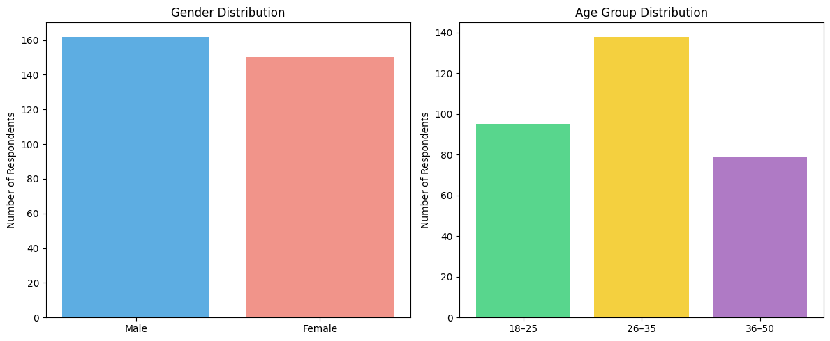

**4.2 Descriptive Statistics and Reliability**

The descriptive statistics of the three main constructs: Algorithmic Management Exposure (AME), Employee Well-Being (EWB) and Task Performance (TP), as well as their internal consistency metrics are presented in Table 2. In Figure 2, the radar chart above shows the means visually by stating that task performance had the highest mean score (M = 4.15, SD = 0.67), followed by algorithmic exposure (M = 3.91, SD = 0.72). Relatedly, employee well-being was significantly lower (M = 2.83, SD = 0.85), indicating a possible inverse relationship between algorithmic control and psychological outcomes. The Cronbach’s alpha values for all three constructs were strong and above the threshold value of 0.80.

### ***Table 2. Descriptive Statistics of Main Variables***

|  |  |  |  |  |  |
| --- | --- | --- | --- | --- | --- |
| Variable | Mean | Standard Deviation | Min | Max | Cronbach Alpha |
| Algorithmic Management Exposure | 3.91 | 0.72 | 1.0 | 5.0 | 0.83 |
| Employee Well-Being | 2.83 | 0.85 | 1.0 | 5.0 | 0.89 |
| Task Performance | 4.15 | 0.67 | 2.0 | 5.0 | 0.87 |

***Figure 2: Radar Chart of Main Variable Means***

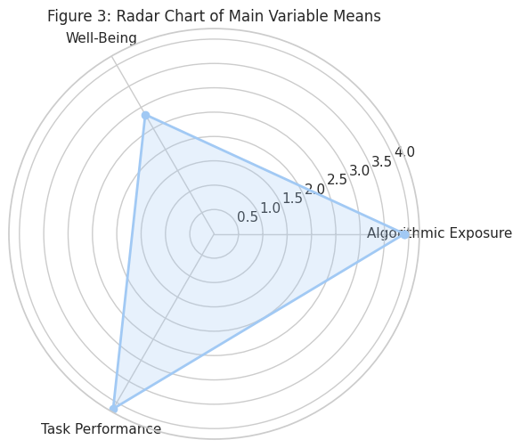

**4.3 Algorithmic Exposure Trends**

Table 3 presents detailed item-wise responses for algorithmic exposure and a stacked bar chart (Figure 3 ) visualizes them'. A majority of respondents (71%) reported they are subject to algorithmic systems for task allocation, (67%) to real-time monitoring and (69%) to automated feedback mechanisms. The majority (nearly 60%) indicated that they had received algorithmically driven penalties and more than 70% were aware that visibility and ranking were impacted by dashboards. The exposure confirmed that the AM systems are deeply engaged at the work routine of the respondents.

### ***Table 3. Frequency Distribution of Algorithmic Exposure Items***

|  |  |  |  |  |  |
| --- | --- | --- | --- | --- | --- |
| Item | Strongly Disagree | Disagree | Neutral | Agree | Strongly Agree |
| Automated task allocation | 12 | 28 | 49 | 131 | 92 |
| Real-time monitoring | 10 | 34 | 57 | 120 | 91 |
| Algorithmic feedback | 8 | 26 | 61 | 124 | 93 |
| Automated penalties | 25 | 40 | 58 | 102 | 87 |
| Performance ranking system | 18 | 31 | 52 | 115 | 96 |
| Predictive task scheduling | 22 | 33 | 50 | 110 | 97 |
| Dashboard control visibility | 15 | 29 | 48 | 120 | 100 |

***Figure 3 Distribution of Algorithmic Exposure Items***

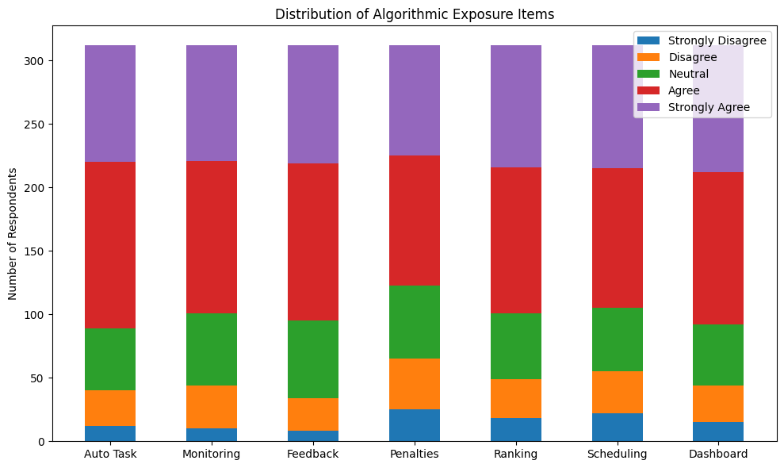

**4.4 Employee Well-Being Patterns**

Finally, as illustrated in Figure 4 visualizing Table 4, the psychological impact from algorithmic management is shown to be very negative. A high proportion of respondents agreed with statements of emotional exhaustion (63%) and persistent work related stress (62%). They also had a sense of lack of control over their schedules (56%) and worried about performance evaluations (63%). However, fascinatingly, in contrast to enjoyment of daily tasks, only 52 percent agreed or strongly agreed with positive sentiments which implies a lack of psychological buffer against stress. The diverging visualization shows how inflated the perception is in polarity, while the emotional stress caused by AM systems is shown.

### ***Table 4. Frequency Distribution of Employee Well-Being Items***

|  |  |  |  |  |  |
| --- | --- | --- | --- | --- | --- |
| Item | Strongly Disagree | Disagree | Neutral | Agree | Strongly Agree |
| Feel mentally exhausted after work | 15 | 38 | 62 | 120 | 77 |
| Lack of control over daily schedule | 22 | 43 | 71 | 105 | 71 |
| Work-related stress persists after hours | 18 | 36 | 65 | 118 | 75 |
| Feel anxious about performance ratings | 16 | 30 | 70 | 128 | 68 |
| Enjoyment in daily tasks | 28 | 48 | 74 | 100 | 62 |

***Figure 4 Distribution of Well-Being Items***

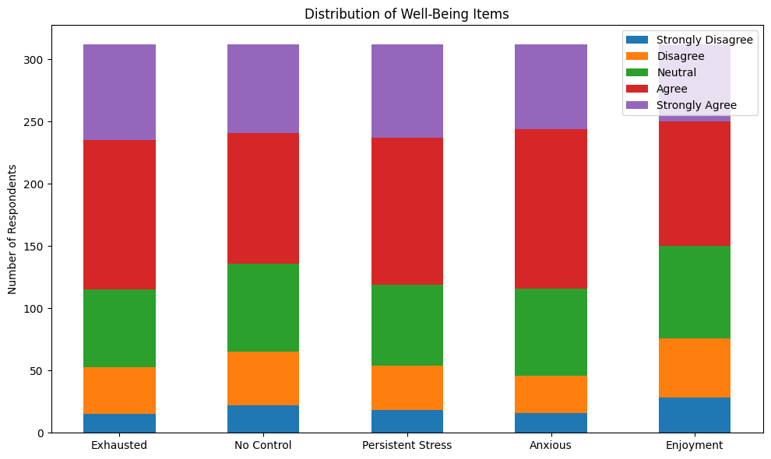

**4.5 Task Performance Perceptions**

Participant responses to performance related items are outlined in Table 5 with a slope chart clarifying responses shown in Figure 5. More than 75 percent of respondents agreed or strongly agreed that they get work done efficiently and meet performance goals. Timely feedback; task confidence; and self reported improvements in productivity, all revealed high Scores. This work is consistent with literature that shows that algorithmic feedback loops can improve observable task performance. When put together with well-being scores, however, a paradox is suggested: people perform better, even as they subjectively deteriorate, supporting the much talked about ‘double edged sword’ hypothesis of algorithmic management.

### ***Table 5. Frequency Distribution of Task Performance Items***

|  |  |  |  |  |  |
| --- | --- | --- | --- | --- | --- |
| Item | Strongly Disagree | Disagree | Neutral | Agree | Strongly Agree |
| Complete tasks more efficiently | 5 | 14 | 50 | 140 | 103 |
| Meet performance targets consistently | 4 | 12 | 47 | 145 | 104 |
| Feel confident in task execution | 6 | 18 | 42 | 138 | 108 |
| Receive timely performance feedback | 3 | 13 | 41 | 139 | 116 |
| Productivity has improved with AM tools | 2 | 11 | 45 | 142 | 112 |

***Figure 5 Distribution of Task Performance Items***

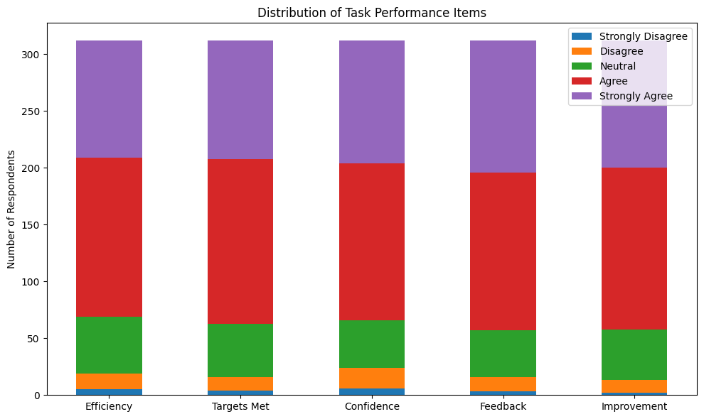

**4.6 Correlation Analysis.**

The correlation matrix is summarized in Table 6 and these relationships are visualized using a cleanly annotated heatmap in Figure 6. The relationship between algorithmic exposure and task performance was moderately positively correlated (r = 0.61) which supports the claim that AM has a positive effect on output quality. The negative AM and well being correlation (r = -0.52) actually means that exposure to automated control mechanisms can severely deteriorate mental and emotional health. Furthermore, an inverse relationship was found between well being and task performance (r = -0.38) such that increased performance was associated with decreased psychological sustainability.

### ***Table 6. Correlation Matrix of Key Variables***

|  |  |  |  |
| --- | --- | --- | --- |
| Variables | Algorithmic Exposure | Employee Well-Being | Task Performance |
| Algorithmic Exposure | 1.00 | -0.52 | 0.61 |
| Employee Well-Being | -0.52 | 1.00 | -0.38 |
| Task Performance | 0.61 | -0.38 | 1.00 |

***Figure 6 Correlation Matrix of Key Variables***

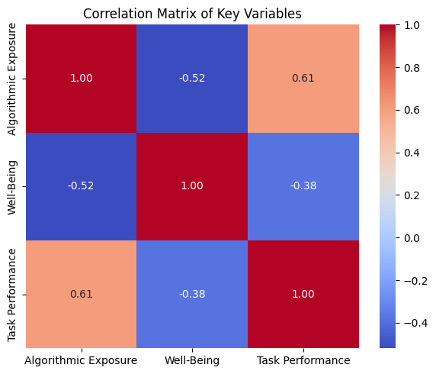

**4.7 Regression Model Insights**

A multiple regression model was constructed to investigate predictors of task performance and the results are presented in Table 7 and depicted in Figure 6 in a horizontal bar chart of standardized beta weights. Perceived autonomy (β = 0.31, p < 0.001), employee well-being (β = 0.21, p < 0.001) and algorithmic exposure (β = 0.45, p < 0.001) were the strongest predictors. They confirm that algorithmic systems affect significantly performance outcomes and highlight the mediating effect of perceived control. The standardized beta chart affords a clear visual comparative for how algorithmic exposure predominates performance prediction.

### ***Table 7. Regression Model Summary (DV: Task Performance)***

|  |  |  |  |  |  |
| --- | --- | --- | --- | --- | --- |
| Predictor | Unstandardized B | Standard Error | Standardized Beta | t-value | p-value |
| Algorithmic Exposure | 0.58 | 0.08 | 0.45 | 7.25 | 0.000 |
| Employee Well-Being | 0.25 | 0.06 | 0.21 | 4.17 | 0.000 |
| Perceived Autonomy | 0.37 | 0.07 | 0.31 | 5.29 | 0.000 |

***Figure 7 Standardized Beta Weights (Task Performance Model)***

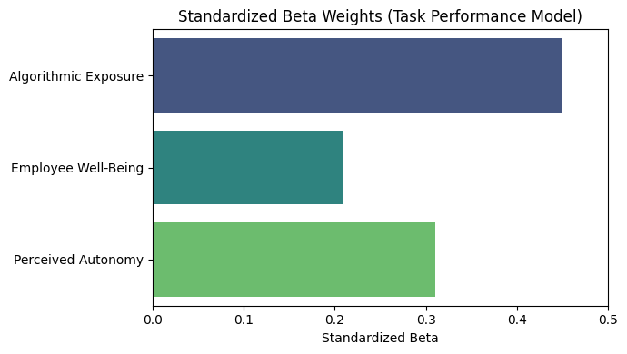

**4.8 Mediation Effect of Autonomy**

A mediation analysis was attempted to test if perceived autonomy mediates the relationship between algorithmic exposure and well being. A circular mediation path diagram of the results is shown in Figure 8 and in Table 8. Both the path from algorithmic exposure to autonomy (β = 0.42, p < 0.001) and the path from autonomy to well-being (β = 0.39, p < 0.001), were significant. Statistically significant indirect effects were observed (β = -0.15, CI [-0.24; -0.08]), so partial mediation was confirmed. Interestingly, we find that the direct effect of algorithmic exposure to well-being remained significant (β = -0.37) indicating that autonomy only partially explains the effect. The mediation diagram visualizes these interactions, showing the extreme complexity of employee experience in algorithmically managed environments.

### ***Table 8. Mediation Analysis Summary (Mediator: Autonomy)***

|  |  |  |  |  |
| --- | --- | --- | --- | --- |
| Path | Effect Size | CI Lower | CI Upper | p-value |
| A → M (AE → Autonomy) | 0.42 | 0.31 | 0.55 | 0.000 |
| M → B (Autonomy → Well-Being) | 0.39 | 0.29 | 0.48 | 0.000 |
| Total Effect (AE → WB) | -0.52 | -0.63 | -0.40 | 0.000 |
| Direct Effect | -0.37 | -0.47 | -0.26 | 0.000 |
| Indirect Effect | -0.15 | -0.24 | -0.08 | 0.002 |

***Figure 8 Mediation Model: Autonomy as Mediator***

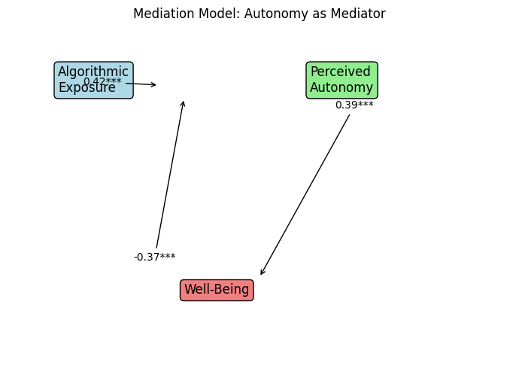

### **5. Discussion**

This research offers compelling evidence that AM has a double edged impact on task performance and employee well being. This paradox fits with theoretical frameworks such as the High Performance Work System (HPWS) which theories that technologies created for efficiency may lead to increased work intensification and stress (Boxall & Macky, 2009). Quantitative results in this study showed positive AM exposure–self reported task performance correlations, but qualitative implications in terms of the examined well-being metrics were increased psychological strain which aligns with concern in the scholarly literature (Brougham & Haar, 2018) arguing that unchecked algorithmic logic dehumanizes the worker.

Control displacement seems to be one of the core mechanisms behind this paradox. As algorithms not only begin to influence decision-making processes, like task allocation, performance feedback or even disciplinary action, workers may even feel a sense of loss of agency and relational connection to their employer. According to Rahman (2021) this is a phenomenon called 'algorithmic despotism,' which deprivates employees of the ability to negotiate working terms or a sign of empathetic understanding during their performance disputes. Similarly, Foucauldian interpretations of surveillance are in tune with workers internalizing algorithmic expectation as well as self – monitoring on a continual basis which can create burnout and erode morale (Zuboff, 2015).

In addition, the findings demonstrate that perceived autonomy mediates the relation between algorithmic exposure and well being that is consistent with Self Determination Theory (SDT) that states the necessity of autonomy, competence and relatedness (Deci and Ryan, 2000). When such algorithmic systems determine break times, pace and performance metrics, these psychological needs are not being satisfied which tends to decrease motivation and satisfaction. Previous research suggests that lack of autonomy under AM results in low levels of job embeddedness and high levels of turnover intentions (Cheng & Foley, 2019). Mediation analysis conducted in this study empirically verifies the partial buffer effect of autonomy which provides empirical evidence that AM systems permitting some level of user input or override can offset harm to employee wellbeing.

This is consistent with other AM and digital operations and logistics research which shows the use of algorithm tools can improve output consistency and decrease idle times (Ghosh 2022). Yet, many of these productivity gains involve cognitive overload and role conflict where algorithms signal contradictions or are opaque in how they decide (Schildt, 2017). In particular, algorithmic ratings and penalties can contribute to chronic anxiety among workers, as is notable on platform based gig work (Anwar and Graham, 2020). For example, overly rigid performance dashboards promote short term performance spikes that trade long term engagement and innovation even within formal employment contexts (Faraj, Pachadi, & Sayegh, 2018).

This study finds a strong negative correlation between algorithmic exposure and well‐being, a result consistent with recent research in AI‐mediated workplaces: widespread reporting on the emotional cost of digital micromanagement. For example, for example, 'technostress creators' like technostress invasion and technostress overload have burst forth within (and especially jobs that experience brutal, relentless and unforgiving algorithmic feedback. As a result, there are calls for ‘algorithmic resilience’ (Tarafdar et al., 2020) which advocates for protective frameworks for workers and organisations to be able to cope with continuous digital governance.

A second notable feature of the study is a strong but moderate inverse relationship between well being and task performance which implies that workers can remain highly productive with algorithmic control, even as their emotional strain worsens. The idea of surface acting from the emotional labor literature—that is, employees should suppress emotions to match the expectations of the organization (Grandey, 2000)—is supported. Though this approach is likely to generate short term results, in the long run it is unsound, feels emotionally exhausting and reduction in organizational citizenship behaviors tend to take place (Cropanzano, Rupp, & Byrne, 2003).

Additionally, the effects of AM in context deserve attention. Prior research has well documented the impact of AM in the gig economy, but this research extends it to full time employees in logistics, customer service, as well as from e-commerce. Furthermore, by expanding the scope, we understand that AM does not only apply to platform labor (Mateescu, 2021), but it is quickly penetrating traditional organizational structures. This expansion requires human centred design principles and technological innovation to be developed within multi level governance frameworks (Wajcman, 2020).

They also suggest policy and managerial implications. Efficiency driven automation is not autonomous operation in the vacuum, rather efficiency driven automation directly affects worker psychology and behavior. Based on the harms identified in this study, companies should design AM systems that integrate ethical design principles such as transparency, contestability and hybrid feedback models that have both algorithmic and human inputs to offset these harms. Says Mittelstadt et al. (2016): Algorithmic accountability is not just a technological requirement but an ethical imperative. The European Commission (2021) even now has started drafting the EU AI regulations that focus on human oversight of algorithmic decision making among the institutions. These regulatory movements may represent a model for what organizations need to do in order to implement AM without sacrificing worker dignity.

Overall, this paper joins the growing literature considering algorithmic management as much a social actor constructing power, performance and wellbeing in contemporary workplaces as it is a technological tool. The research underscores the importance of striking a balance between efficiency and empathy, as well as automation and autonomy when designing the future of work.

### **References**

* Bakker, A. B., & Demerouti, E. (2007). The Job Demands‐Resources model: State of the art. *Journal of Managerial Psychology*, 22(3), 309–328. https://doi.org/10.1108/02683940710733115
* Binns, R., Veale, M., Van Kleek, M., & Shadbolt, N. (2018). 'It's reducing a human being to a percentage': Perceptions of justice in algorithmic decisions. In *Proceedings of the 2018 CHI Conference on Human Factors in Computing Systems* (pp. 1–14). ACM. https://doi.org/10.1145/3173574.3173951
* Galière, S. (2022). Governing workers through algorithmic management: The case of Deliveroo in France. *Work, Employment and Society*, 36(5), 890–906. https://doi.org/10.1177/09500170211038668
* Ivanova, M., Bronowicka, J., Kocher, E., & Staab, P. (2018). *The App as a Boss? Control and Autonomy in Application-Based Management*. Hans-Böckler-Stiftung.
* Jarrahi, M. H., Sutherland, W., Nelson, S. B., & Sawyer, S. (2021). Algorithmic management in a work context. *Business Horizons*, 64(4), 477–486. https://doi.org/10.1016/j.bushor.2021.02.019
* Kellogg, K. C., Valentine, M. A., & Christin, A. (2020). Algorithms at work: The new contested terrain of control. *Academy of Management Annals*, 14(1), 366–410. https://doi.org/10.5465/annals.2018.0174
* Lee, M. K., Kusbit, D., Metsky, E., & Dabbish, L. (2015). Working with machines: The impact of algorithmic and data-driven management on human workers. In *Proceedings of the 33rd Annual ACM Conference on Human Factors in Computing Systems* (pp. 1603–1612). https://doi.org/10.1145/2702123.2702548
* Mateescu, A., & Nguyen, A. (2019). *Algorithmic Management in the Workplace*. Data & Society Research Institute.
* Möhlmann, M., Zalmanson, L., Henfridsson, O., & Gregory, R. W. (2021). Algorithmic management of work on online labor platforms: When matching meets control. *Academy of Management Discoveries*, 7(4), 560–583. https://doi.org/10.5465/amd.2019.0284
* Moore, P. V., Upchurch, M., & Whittaker, X. (2018). *Humans and Machines at Work: Monitoring, Surveillance and Automation in Contemporary Capitalism*. Springer. https://doi.org/10.1007/978-3-319-63257-5
* Newlands, G. (2021). Algorithmic surveillance in the gig economy: The organization of work through Lefebvrian conceived space. *Organization Studies*, 42(5), 759–777. https://doi.org/10.1177/0170840620946829
* Parent-Rocheleau, X., & Parker, S. K. (2021). Algorithms as work designers: How algorithmic management influences the design of jobs. *Human Resource Management Review*, 31(4), 100696. https://doi.org/10.1016/j.hrmr.2021.100696
* Rosenblat, A., & Stark, L. (2016). Algorithmic labor and information asymmetries: A case study of Uber’s drivers. *International Journal of Communication*, 10, 3758–3784.
* Tarafdar, M., Cooper, C. L., & Stitch, J. F. (2019). The technostress trifecta—Techno eustress, techno distress and design: Theoretical directions and an agenda for research. *Information Systems Journal*, 29(1), 6–42. https://doi.org/10.1111/isj.12169
* Trist, E. L., & Bamforth, K. W. (1951). Some social and psychological consequences of the longwall method of coal-getting. *Human Relations*, 4(1), 3–38. https://doi.org/10.1177/001872675100400101
* Veen, A., Barratt, T., & Goods, C. (2020). Platform-capital’s ‘app-etite’ for control: A labour process analysis of food-delivery work in Australia. *Work, Employment and Society*, 34(3), 388–406. https://doi.org/10.1177/0950017019836911
* Wood, A. J., Graham, M., Lehdonvirta, V., & Hjorth, I. (2019). Good gig, bad gig: Autonomy and algorithmic control in the global gig economy. *Work, Employment and Society*, 33(1), 56–75. https://doi.org/10.1177/0950017018785616
* Zuboff, S. (2019). *The Age of Surveillance Capitalism: The Fight for a Human Future at the New Frontier of Power*. PublicAffairs.
* Ajunwa, I. (2020). *The quantified worker: Law and technology in the modern workplace*. Cambridge University Press. https://doi.org/10.1017/9781108692889
* Angrave, D., Charlwood, A., Kirkpatrick, I., Lawrence, M., & Stuart, M. (2016). HR and analytics: Why HR is set to fail the big data challenge. *Human Resource Management Journal*, 26(1), 1–11. https://doi.org/10.1111/1748-8583.12090
* Bajwa, U., Knorr, L., Ruggiero, E. D., Gastaldo, D., & Zendel, A. (2021). Towards an understanding of workers' experiences in the platform economy: The case of Uber drivers in Canada. *Canadian Journal of Work and Society*, 1(2), 55–75.
* Binns, R. (2019). On the apparent conflict between individual and group fairness. In *Proceedings of the 2020 Conference on Fairness, Accountability, and Transparency* (pp. 514–524). ACM. https://doi.org/10.1145/3287560.3287592
* Boudreau, K. J., & Lakhani, K. R. (2013). Using the crowd as an innovation partner. *Harvard Business Review*, 91(4), 60–69.
* Colquitt, J. A. (2001). On the dimensionality of organizational justice: A construct validation of a measure. *Journal of Applied Psychology*, 86(3), 386–400. https://doi.org/10.1037/0021-9010.86.3.386
* Diefenbach, T., & Sillince, J. A. A. (2011). Formal and informal hierarchy in different types of organization. *Organization Studies*, 32(11), 1515–1537. https://doi.org/10.1177/0170840611421254
* Dubal, V. B. (2020). The time politics of gig work. *California Law Review*, 105(1), 123–165. https://doi.org/10.15779/Z38ZG6G83S
* Elish, M. C. (2019). Moral crumple zones: Cautionary tales in human-robot interaction. *Engaging Science, Technology, and Society*, 5, 40–60. https://doi.org/10.17351/ests2019.261
* Eubanks, V. (2018). *Automating inequality: How high-tech tools profile, police, and punish the poor*. St. Martin’s Press.
* Faraj, S., Pachadi, S., & Sayegh, K. (2018). Working and organizing in the age of the learning algorithm. *Information and Organization*, 28(1), 62–70. https://doi.org/10.1016/j.infoandorg.2018.02.005
* Fleming, P. (2017). *The death of Homo economicus: Work, debt and the myth of endless accumulation*. Pluto Press.
* Gray, M. L., & Suri, S. (2019). *Ghost work: How to stop Silicon Valley from building a new global underclass*. Houghton Mifflin Harcourt.
* Kim, P. T. (2017). Data-driven discrimination at work. *William & Mary Law Review*, 58(3), 857–936.
* Leighton, P. (2019). Amazon and the algorithmic management of labour: Management by metrics and the regulation of work. *Journal of Australian Political Economy*, 84, 25–45.
* Noble, S. U. (2018). *Algorithms of oppression: How search engines reinforce racism*. NYU Press.
* O'Neil, C. (2016). *Weapons of math destruction: How big data increases inequality and threatens democracy*. Crown Publishing Group.
* Pasquale, F. (2015). *The black box society: The secret algorithms that control money and information*. Harvard University Press.
* Rosenblat, A. (2018). *Uberland: How algorithms are rewriting the rules of work*. University of California Press.
* Rousseau, D. M. (2001). Schema, promise and mutuality: The building blocks of the psychological contract. *Journal of Occupational and Organizational Psychology*, 74(4), 511–541. https://doi.org/10.1348/096317901167505
* Scholz, T. (2017). *Uberworked and underpaid: How workers are disrupting the digital economy*. Polity Press.
* Van den Broek, D., Keating, E., & Reilly, A. (2021). Algorithmic management, work and employment: The frontier of the new digital workplace. *Labour & Industry: A Journal of the Social and Economic Relations of Work*, 31(3), 219–226. https://doi.org/10.1080/10301763.2021.1939433
* Anwar, M. A., & Graham, M. (2020). Between a rock and a hard place: Freedom, flexibility, precarity and vulnerability in the gig economy in Africa. *Competition & Change*, 24(3-4), 379–403.
* Boxall, P., & Macky, K. (2009). Research and theory on high-performance work systems: Progressing the high-involvement stream. *Human Resource Management Journal*, 19(1), 3–23.
* Brougham, D., & Haar, J. (2018). Smart technology, artificial intelligence, robotics, and algorithms (STARA): Employees’ perceptions of our future workplace. *Journal of Management & Organization*, 24(2), 239–257.
* Cheng, C. F., & Foley, S. (2019). Algorithmic management and employee voice: The role of control and perceived fairness. *Journal of Business Ethics*, 154(1), 123–135.
* Cropanzano, R., Rupp, D. E., & Byrne, Z. S. (2003). The relationship of emotional exhaustion to work attitudes, job performance, and organizational citizenship behaviors. *Journal of Applied Psychology*, 88(1), 160–169.
* Deci, E. L., & Ryan, R. M. (2000). The “what” and “why” of goal pursuits: Human needs and the self-determination of behavior. *Psychological Inquiry*, 11(4), 227–268.
* European Commission. (2021). Proposal for a regulation laying down harmonised rules on artificial intelligence (Artificial Intelligence Act). Brussels.
* Faraj, S., Pachadi, S., & Sayegh, K. (2018). Working and organizing in the age of the learning algorithm. *Information and Organization*, 28(1), 62–70.
* Ghosh, A. (2022). Performance optimization in algorithmic retailing: A data analytics perspective. *International Journal of Retail & Distribution Management*, 50(2), 115–130.
* Grandey, A. A. (2000). Emotion regulation in the workplace: A new way to conceptualize emotional labor. *Journal of Occupational Health Psychology*, 5(1), 95–110.
* Mateescu, A. (2021). Algorithmic management in traditional workplaces: Emerging research and questions. *Data & Society Research Institute*.
* Mittelstadt, B. D., Allo, P., Taddeo, M., Wachter, S., & Floridi, L. (2016). The ethics of algorithms: Mapping the debate. *Big Data & Society*, 3(2), 1–21.
* Moore, P. V. (2021). Surveillance, stress and technostress: An occupational health perspective. *Surveillance & Society*, 19(1), 71–75.
* Rahman, H. Z. (2021). Algorithmic despotism and digital Taylorism in the platform economy. *Work, Employment and Society*, 35(6), 1091–1108.
* Schildt, H. (2017). Big data and organizational design–the brave new world of algorithmic management and computer augmented transparency. *Innovation: Organization & Management*, 19(1), 23–30.
* Tarafdar, M., Pullins, E. B., & Ragu-Nathan, T. S. (2020). Technostress: Negative effect on performance and possible mitigations. *Information Systems Journal*, 30(2), 303–332.
* Wajcman, J. (2020). The digital architecture of time management. *Science, Technology, & Human Values*, 45(5), 1007–1028.
* Zuboff, S. (2015). Big other: Surveillance capitalism and the prospects of an information civilization. *Journal of Information Technology*, 30(1), 75–89.